MICRO: SAMPLE EXAM QUESTIONS

EXAM 1
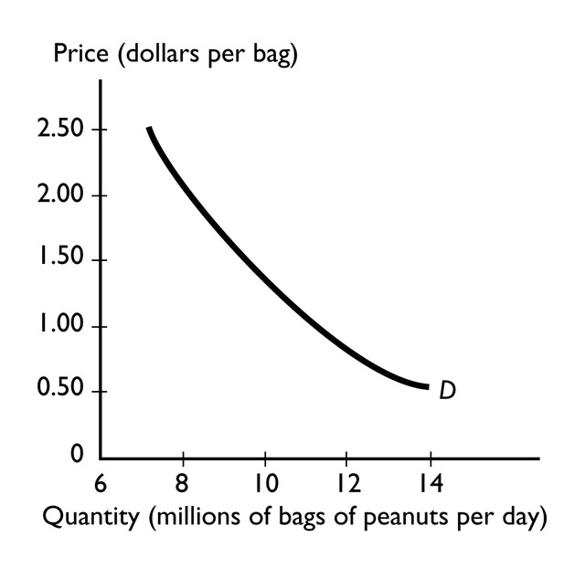

1)
The graph illustrates the demand for peanuts. Peanuts are a normal good because the

A)
peanuts have both substitutes and complements.

B)
demand curve shows that if the price of peanuts rises, there is a movement along the demand curve to a lower quantity demanded.

C)
demand for peanuts increases when income increases.

D)
demand curve for peanuts slopes downward.

E)
demand for peanuts increases when the price of one of its substitutes rises.

Topic:
Normal goods

Skill:
Level 2: Using definitions

Section:
Checkpoint 4.1

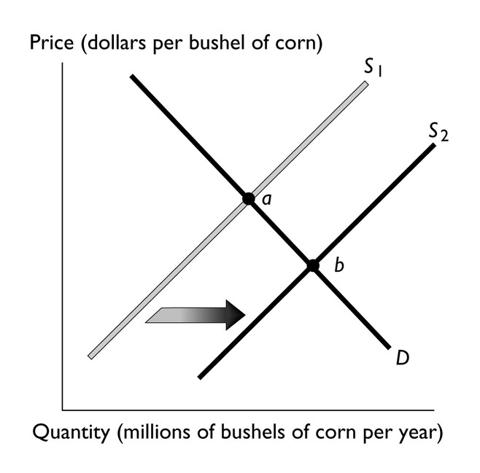

2)
The above figure illustrates the market for corn. If point "a" represents the original equilibrium and point "b" the new equilibrium, which of the following could have caused the change?

A)
an increase in labor costs of producing corn

B)
an improvement in the technology of producing corn

C)
an increase in consumers' income if corn is an inferior good

D)
an increase in consumers' preferences for corn

E)
an increase in consumers' income if corn is a normal good

Topic:
Shifts of the supply curve, productivity

Skill:
Level 3: Using models

Section:
Checkpoint 4.2

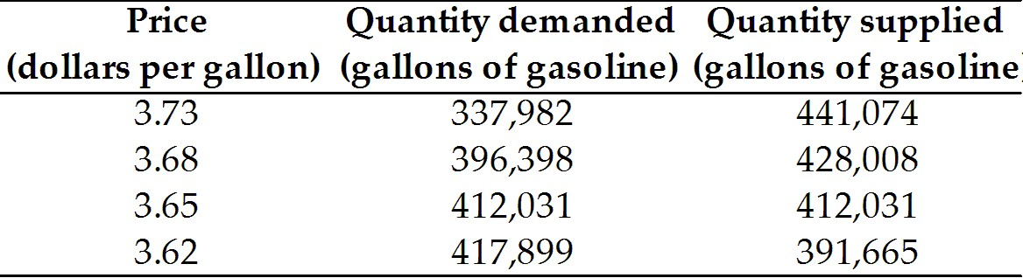

3)
The table above shows the situation in the gasoline market in Tulsa, Oklahoma. If the price of a gallon of gasoline is $3.62, then

A)
there is a surplus of gasoline in Tulsa.

B)
the gasoline market in Tulsa is in equilibrium.

C)
there is a shortage of gasoline in Tulsa.

D)
without more information we cannot determine if there is a surplus, a shortage, or an equilibrium in the gasoline market in Tulsa.

E)
there is neither a surplus nor a shortage but the market is NOT in equilibrium.

Topic:
Shortage

Skill:
Level 3: Using models

Section:
Checkpoint 4.3

4)
Consider the market for peanut butter. If there is a decrease in the price of deli turkey slices (a substitute in consumption for peanut butter) along with a decrease in the price of peanut brittle (a substitute in production for peanut butter), the

A)
equilibrium price of peanut butter definitely falls.

B)
equilibrium price of peanut butter definitely rises.

C)
equilibrium price of peanut butter might rise or fall.

D)
equilibrium quantity of peanut butter definitely increases.

E)
equilibrium quantity of peanut definitely decreases.

Topic:
Integrative

Skill:
Level 3: Using models

Section:
Integrative

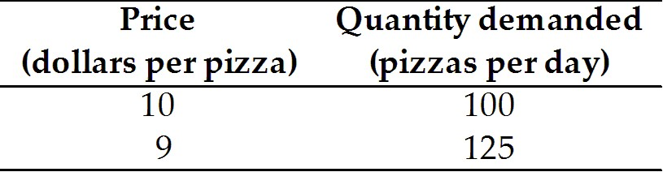

5)
The data in the table above give two points on the demand curve for pizza. Using the midpoint method, when the price of a pizza falls from $10 to $9, what is the percentage change in price?

A)
15.5 percent
B)
8.2 percent
C)
10.5 percent
D)
5.0 percent
E)
1.0 percent

Topic:
Midpoint formula

Skill:
Level 3: Using models

Section:
Checkpoint 5.1

6)
When income increases from $30,000 a year to $40,000 a year, the quantity demanded of weekend vacations by Sara increases from 2 a year to 5 a year. For Sara, the income elasticity of demand of weekend vacations is ________ and weekend vacations are ________ good.

A)
1/3; a normal

B)
4.5 a normal

C)
1/3; an inferior

D)
-4.5; an inferior

E)
3; a normal

Topic:
Income elasticity of demand, formula

Skill:
Level 3: Using models

Section:
Checkpoint 5.3

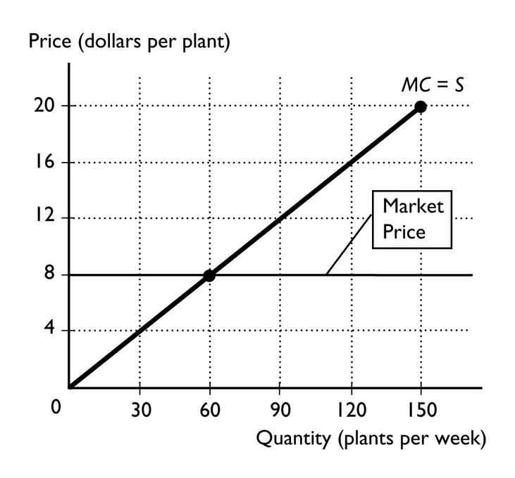

7)
Bill and Krista sell potted plants from a roadside stand. The figure above shows Bill and Krista's marginal cost curve and the market price. If Bill and Krista sell 60 plants per week, their producer surplus from the 60th plant will equal

A)
$8.

B)
$20.

C)
$0.

D)
$480.

E)
More information is needed to answer the question.

Topic:
Producer surplus

Skill:
Level 3: Using models

Section:
Checkpoint 6.3

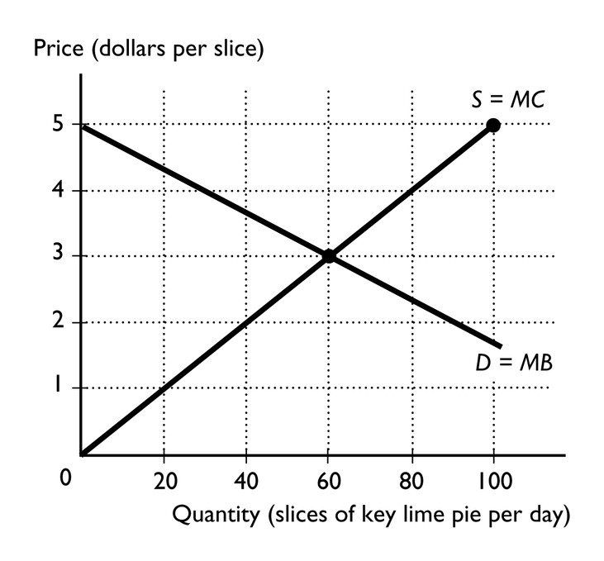

8)
The figure above represents the competitive market for slices of key lime pie. When 60 slices are produced, the marginal cost

A)
equals the marginal benefit.

B)
is less than the marginal benefit.

C)
exceeds the marginal benefit.

D)
equals the deadweight loss on the 60th slice.

E)
is not defined.

Topic:
Market efficiency

Skill:
Level 3: Using models

Section:
Checkpoint 6.4

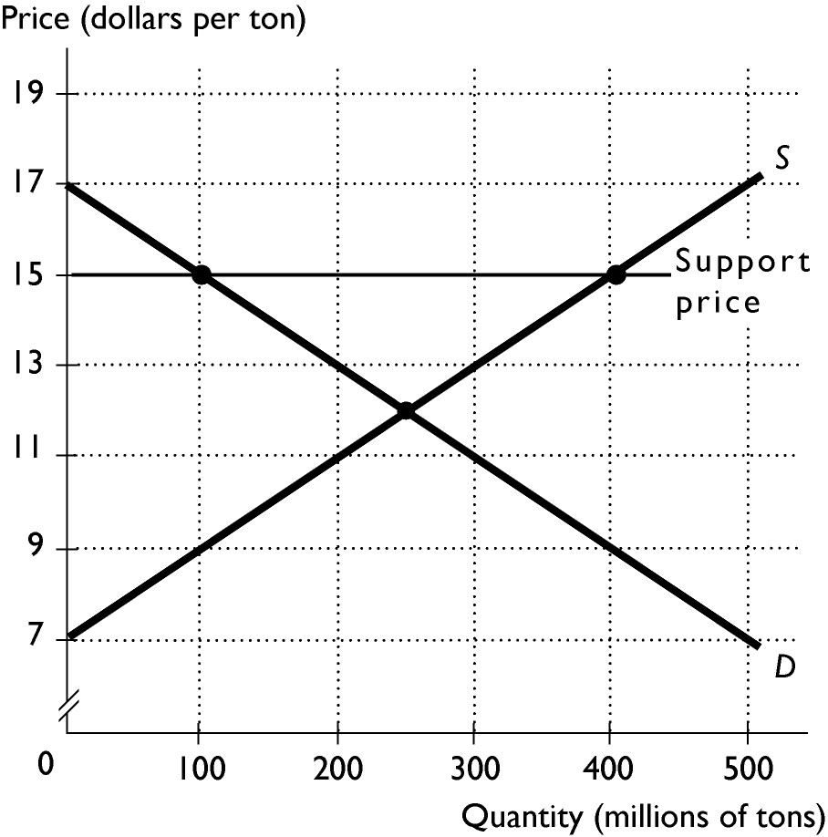

9)
The above figure shows the domestic market for wheat. Suppose this market is isolated from global competition and the government intervenes by setting a support price of $15 a ton. The quantity produced once the price support is in place is

A)
300 million tons.

B)
200 million tons.

C)
250 million tons.

D)
400 million tons.

E)
100 million tons.

Topic:
Price support

Skill:
Level 3: Using models

Section:
Checkpoint 7.3

10)
If the government imposes an effective ________, output decreases and ________ increases.

A)
price floor; marginal benefit to consumers

B)
price support; consumer surplus

C)
price floor; consumer surplus

D)
price support; total revenue

E)
price ceiling; efficiency

Topic:
Integrative

Skill:
Level 3: Using models

Section:
Integrative

EXAM 2

11)
The imposition of a tax on a good enables the government to

A)
raise the price received by sellers of the goods that have been taxed.

B)
lower the price paid by buyers for the goods that have been taxed.

C)
decrease the deadweight loss in this market.

D)
take part of consumer and producer surplus as tax revenue when the good is purchased.

E)
create a more efficient economic system.

Topic:
Tax incidence, government revenue

Skill:
Level 3: Using models

Section:
Checkpoint 8.1

12)
Joan's income is $60,000 and she pays $6,000 in taxes. Juan's income is $40,000 and he pays $7,000 in taxes. This situation violates

A)
the fair-tax incidence principle.

B)
the benefits principle.

C)
vertical equity.

D)
the big tradeoff.

E)
horizontal equity.

Topic:
Vertical equity

Skill:
Level 3: Using models

Section:
Checkpoint 8.3

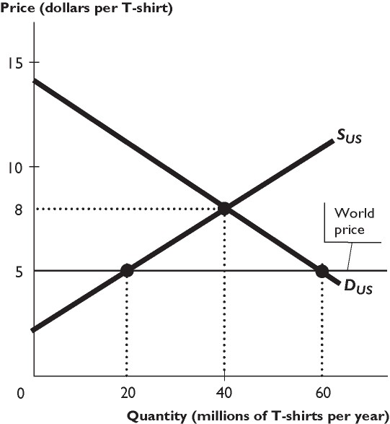
The figure above shows the U.S. market for T-shirts, where SUS is the domestic supply curve and DUS is the domestic demand curve. The United States trades freely with the rest of the world. The world price of a T-shirt is $5.

13)
Based on the figure above, as a result of international trade, U.S. domestic production ________ million T-shirts per year.

A)
increases by 10

B)
increases by 40

C)
increases by 20

D)
decreases by 10

E)
decreases by 20

Topic:
Imports

Skill:
Level 3: Using models

Section:
Checkpoint 9.1

14)
Country A imports 1,000 cars per month. After imposing a $50 per car tariff, imports fall to 800 cars per month. How much does Country A's government collect in tariff revenue?

A)
$40,000
B)
$90,000
C)
$10,000
D)
$60,000
E)
$50,000

Topic:
Effects of tariffs

Skill:
Level 3: Using models

Section:
Checkpoint 9.3

15)
The existence of marginal external benefits for a product like higher education creates a deadweight loss for society because, without government intervention, ________ would be consumed and ________ would be produced.

A)
less than the efficient amount; less than the efficient amount

B)
more than the efficient amount; more than the efficient amount

C)
more than the efficient amount; less than the efficient amount

D)
less than the efficient amount; more than the efficient amount

E)
the efficient amount; the efficient amount

Topic:
Inefficient equilibrium

Skill:
Level 3: Using models

Section:
Checkpoint 11

EXAM 3

16)
Assume you are in a store looking at a shirt you want. You expect to buy the shirt until you look at the price, then you decide the shirt is not a good buy. How can your decision be viewed in economic terms?

A)
The shirt has zero marginal utility for you.

B)
The opportunity cost of the shirt was too low.

C)
The shirt's marginal utility divided by price was too high compared to other goods.

D)
The shirt's marginal utility divided by price was too low compared to other goods.

E)
None of the above answers is correct.

Topic:
Equalize marginal utility per dollar spent

Skill:
Level 3: Using models

Section:
Checkpoint 13

Quantity of  ice cream | Total utility from ice cream
0 | 0
1 | 80
2 | 150
3 | 210
4 | 260

17)
Give the data in the above table, what is the marginal utility of the third unit of ice cream?

A)
210
B)
70
C)
80
D)
230
E)
60

Topic:
Total utility and marginal utility

Skill:
Level 3: Using models

Section:
Checkpoint 13

18)
April quit her job as an accountant at Ernst and Young, where she was paid $45,000 per year. She started her own landscaping business. She rents machines and tools for $50,000 and pays $10,000 as wages to her help. These are her only costs. April earned total revenue of $100,000.

A)
Her accountant calculates her profit as $40,000.

B)
She has an economic loss.

C)
Her explicit cost is $105,000.

D)
Both answers A and B are correct.

E)
Both answers A and C are correct.

Topic:
Economic profit

Skill:
Level 3: Using models

Section:
Checkpoint 14

19)
Jill runs a factory that makes lie detectors in Little Rock, Arkansas. This month, Jill's 34 workers produced 690 machines. Suppose Jill adds one more worker and, as a result, her factory's output increases to 700. Jill's marginal product of labor from the last worker hired equals ________.

A)
20

B)
10

C)
690

D)
700

E)
None of the above answers is correct.

Topic:
Marginal product

Skill:
Level 2: Using definitions

Section:
Checkpoint 14

20)
The long-run average cost curve is U-shaped because of which of the following?

A)
economies and diseconomies of scale

B)
decreasing marginal returns as more labor is hired

C)
decreasing average fixed costs as output is increased

D)
increasing marginal returns as more labor is hired

E)
constant fixed costs as output is increased

Topic:
Long-run average cost curve

Skill:
Level 3: Using models

Section:
Checkpoint 14

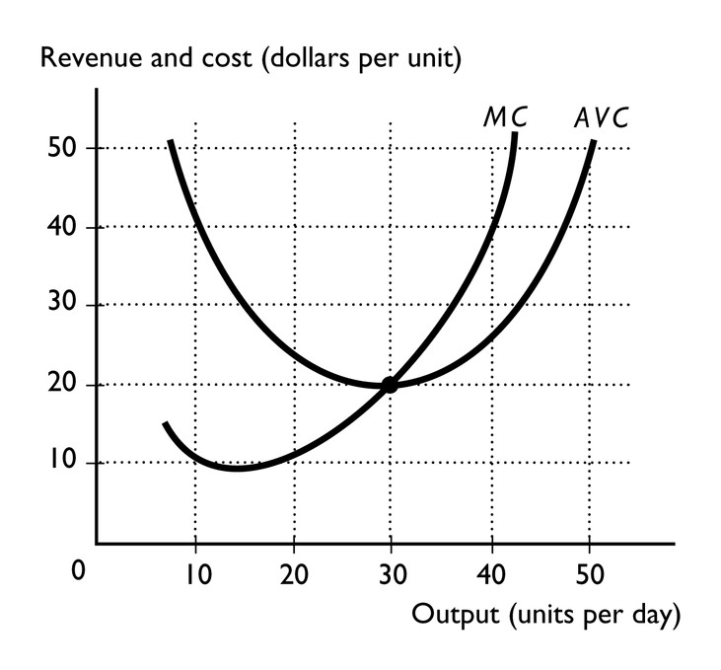

21)
The above figure illustrates a perfectly competitive firm. If the market price is $40 a unit, to maximize its profit (or minimize its loss) the firm should

A)
shut down.

B)
produce 40 units.

C)
produce more than 10 and less than 30 units.

D)
produce 30 units.

E)
produce more than 30 units and less than 40 units..

Topic:
Profit maximization

Skill:
Level 3: Using models

Section:
Checkpoint 15

22)
In a perfectly competitive market, the type of decision a firm has to make is different in the short run than in the long run. Which of the following is an example of a perfectly competitive firm's short-run decision?

A)
the profit-maximizing level of output

B)
whether or not to change its plant size

C)
what price to charge buyers for the product

D)
whether or not to enter or exit an industry

E)
how much to spend on advertising and sales promotion

Topic:
Short-run decisions

Skill:
Level 3: Using models

Section:
Checkpoint 15

EXAM 4

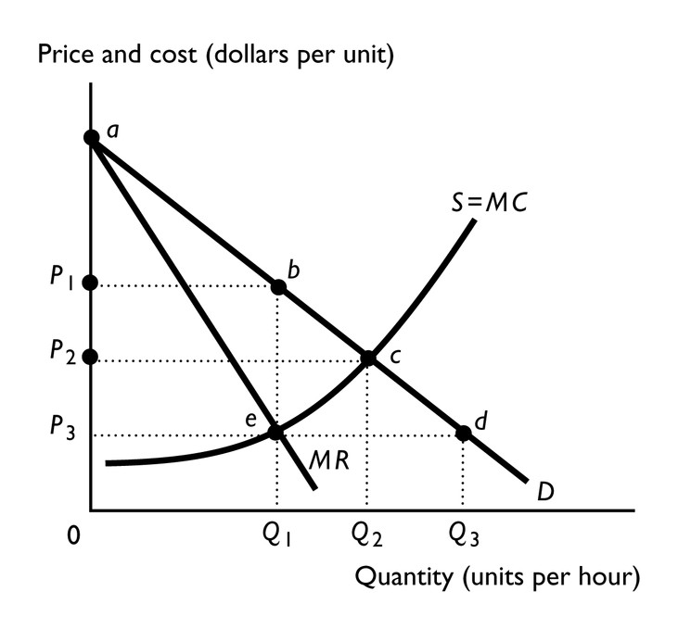

23)
In the above figure, a perfectly competitive market will have a price of ________ and a single-price monopoly will have a price of ________.

A)
P2 and quantity of Q2; P3 and quantity of Q1

B)
P2 and quantity of Q2; P1 and quantity of Q1

C)
P1 and quantity of Q1; P2 and quantity of Q2

D)
P2 and quantity of Q1; P1 and quantity of Q1

E)
P3 and quantity of Q3; P1 and quantity of Q1

Topic:
Monopoly and competition compared, output and price

Skill:
Level 3: Using models

Section:
Checkpoint 16

24)
When a perfectly competitive industry is taken over by a monopoly, some consumer surplus is transferred to the monopolist in the form of

A)
deadweight loss.

B)
average variable cost.

C)
taxes.

D)
economic profit.

E)
marginal cost.

Topic:
Monopoly and competition compared, surpluses

Skill:
Level 4: Applying models

Section:
Checkpoint 16

25)
The process of price cap regulation includes which of the following?
i. a price ceiling.
ii. marginal cost pricing.
iii. average cost pricing

A)
i and ii
B)
ii and iii
C)
ii only
D)
i and iii
E)
i only

Topic:
Price cap regulation

Skill:
Level 1: Definition

Section:
Checkpoint 16

26)
If a natural monopoly is regulated using

A)
an average cost pricing rule, the firm incurs an economic loss.

B)
a marginal cost pricing rule, the firm incurs an economic loss.

C)
a total cost pricing rule, the firm will exit the industry.

D)
a marginal cost pricing rule, the firm maximizes its profit.

E)
an average cost pricing rule, the firm maximizes its profit.

Topic:
Natural monopoly, marginal cost pricing rule

Skill:
Level 2: Using definitions

Section:
Checkpoint 16

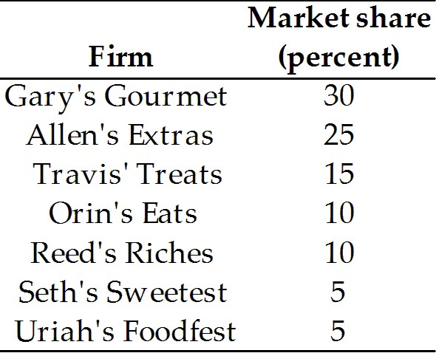

27)
Suppose there are 7 firms in the candy industry with the market shares shown below. What is the HHI for the industry?

A)
100
B)
6400
C)
2000
D)
1850
E)
20

Topic:
Herfindahl-Hirschman Index

Skill:
Level 3: Using models

Section:
Checkpoint 17

28)
The freedom of entry and exit in monopolistic competition means that firms

A)
can enter a market to compete for economic profits and leave when economic losses are being incurred.

B)
enter the market when economic losses are being suffered.

C)
enter the market when normal profits are being earned.

D)
find it easy to permanently earn an economic profit.

E)
exit the market when economic profits are being earned.

Topic:
Monopolistic competition, definition

Skill:
Level 2: Using definitions

Section:
Checkpoint 17

29)
A firm in monopolistic competition that introduces a new and differentiated product will temporarily have a ________ demand for its product and is able to charge a ________.

A)
less elastic; the same price as before

B)
less elastic; a lower price than before

C)
less elastic; a higher price than before

D)
more elastic; a higher price than before

E)
more elastic; a lower price than before

Topic:
Innovation and product development

Skill:
Level 3: Using models

Section:
Checkpoint 17

30)
In the long run, advertising by all firms in a monopolistically competitive industry

A)
decreases all firms' demand.

B)
lowers all firms' prices.

C)
might increase or decrease the firms' prices.

D)
increases all firms' demand.

E)
lowers all firms' costs.

Topic:
Selling costs

Skill:
Level 4: Applying models

Section:
Checkpoint 17

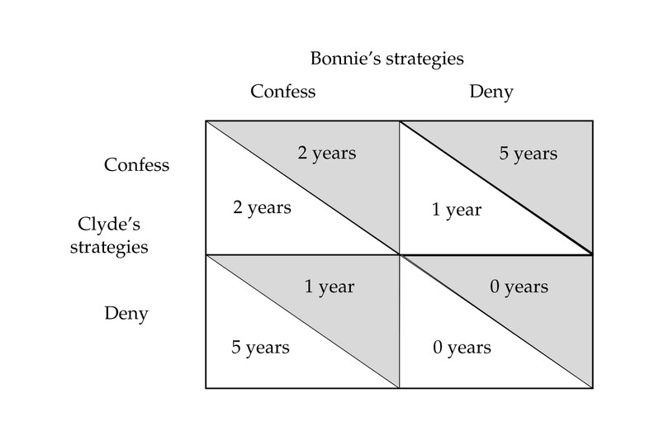

31)
The table above shows the payoff matrix offered to two suspected criminals, Bonnie and Clyde. The payoffs are the years they will spend in prison. The suspected criminals are not allowed to communicate. Given the information in the payoff matrix, the Nash equilibrium is that Bonnie ________ and Clyde ________.

A)
confesses; confesses

B)
denies; either confess or denies, either outcome is consistent with the Nash equilibrium.

C)
denies; denies

D)
denies; confesses

E)
confesses; denies

Topic:
Prisoners' dilemma

Skill:
Level 4: Applying models

Section:
Checkpoint 18

32)
The players in a game theory situation often do not act in their joint interest because of which of the following?

A)
It is not in each player's self-interest to cooperate.

B)
Players strive to minimize their opponents' profits.

C)
Players understand the game but they do not know which action(s) will benefit their joint interest.

D)
They do not realize the benefit of cooperation.

E)
Players do not understand the game and its payoffs.

Topic:
Game theory

Skill:
Level 4: Applying models

Section:
Checkpoint 18

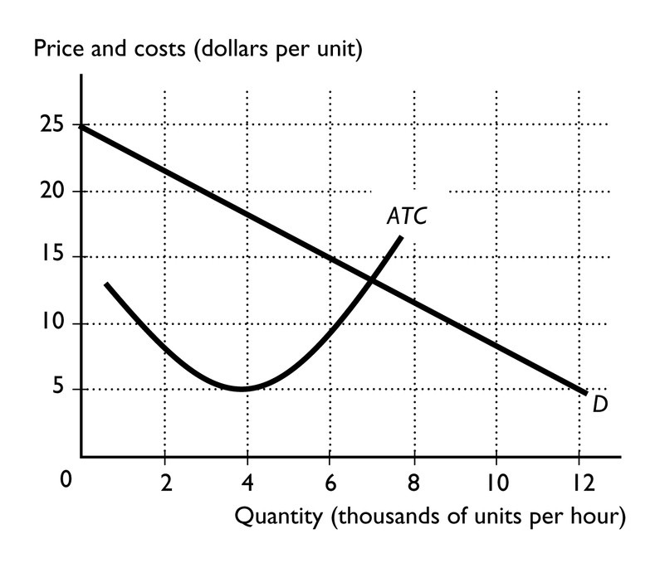

33)
The figure above shows the market demand curve and the ATC curve for a firm. Each firm in the market has the same ATC curve. If the firms in the industry agree to form a cartel, the firms in the industry earn an economic profit if there are ________ firms, each producing ________ units per hour.

A)
4; 3,000
B)
2; 6,000
C)
3; 4,000
D)
2; 12,000
E)
2; 4,000

Topic:
Integrative

Skill:
Level 3: Using models

Section:
Integrative

1)
C

2)
B

3)
C

4)
A

5)
C

6)
E

7)
C

8)
A

9)
D

10)
D

11)
D

12)
C

13)
E

14)
A

15)
A

16)
D

17)
E

18)
D

19)
B

20)
A

21)
B

22)
A

23)
B

24)
D

25)
E

26)
B

27)
C

28)
A

29)
C

30)
C

31)
A

32)
A

33)
E

