MACRO: SAMPLE EXAM QUESTIONS

EXAM 1
1)
When the Dallas Cowboys score more than 30 points in a game, they win the game. This is an example of
A)
ceteris paribus.
B)
an economic theory.
C)
a correlation.
D)
a statement on the margin.
E)
a normative statement.
Topic:
Correlation
Skill:
Level 2: Using definitions
Section:
Checkpoint 1.2

2)
Looking at living standards around the world, one sees that
A)
most people live in countries with average incomes above $20 per day.
B)
most countries have average incomes that are below $3 per day.
C)
the countries of Western Europe have average incomes greater than the United States.
D)
the United States has the highest average income.
E)
incomes in the emerging market economies top the incomes in the advanced economies.
Topic:
Income in the global economy
Skill:
Level 2: Using definitions
Section:
Checkpoint 2.3

3)
What determines the income flows that households receive?
A)
their ownership of factors of production, how much they sell in the factor markets, and the prices received when sold
B)
what they choose to produce, how much is sold, and the price received when sold
C)
an agency of the Federal government
D)
what they choose to consume
E)
financial institutions such as banks
Topic:
Integrative
Skill:
Level 3: Using models
Section:
Integrative

4)
Before the first Gulf War, Kuwait had the capacity to produce a certain amount of oil from its oil wells. After the war, it found that capacity greatly diminished because the oil wells were on fire. Draw Kuwait's PPF before and after the war, assuming that the only two goods produced are oil and food. Further assume that setting the oil wells on fire did not affect Kuwait's ability to produce food. Explain why the PPF before the war is different from the PPF after the war.
Topic:
Production possibilities frontier
Skill:
Level 4: Applying models
Section:
Checkpoint 3.1

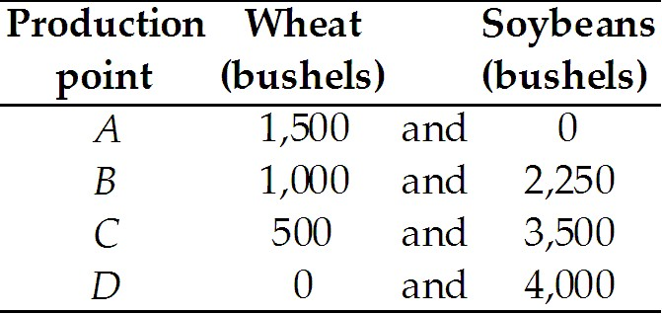

5)
The table above gives the production possibilities frontier for a nation that produces wheat and soybeans. Use the information in that table to complete the table below, which has in it the opportunity costs of moving from one production point to another. Do not forget to note the units of the opportunity costs.

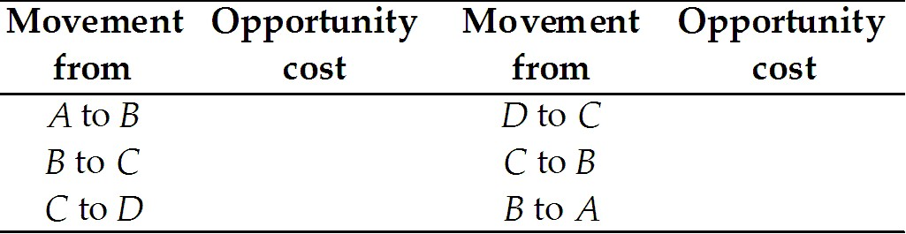

Topic:
Opportunity cost
Skill:
Level 3: Using models
Section:
Checkpoint 3.2

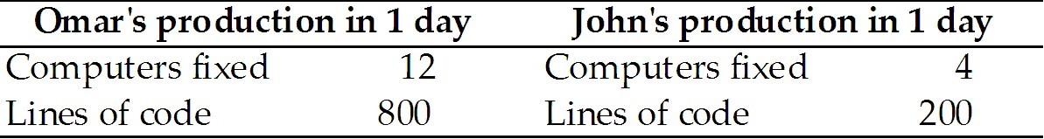

6)
Omar and John can fix computers or write computer programs. The table above shows the number of computers they can fix and the lines of code they can write in a day.
a. Who, if anyone, has the absolute advantage?
b. Who has the comparative advantage in fixing computers? Why?
c. Who has the comparative advantage in writing programs? Why?
Topic:
Comparative advantage
Skill:
Level 3: Using models
Section:
Checkpoint 3.4

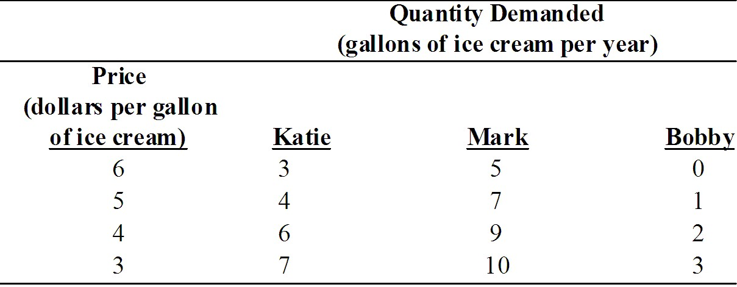

7)
Suppose Katie, Mark, and Bobby are the only consumers in the market for ice cream. Using the demand schedules in the table above, what is the market demand curve for ice cream?
Topic:
Market demand
Skill:
Level 3: Using models
Section:
Checkpoint 4.1

8)
Soft drinks are a normal good. Draw a graph showing the effect of an increase in income on the demand for soft drinks.
Topic:
Change in demand, income
Skill:
Level 3: Using models
Section:
Checkpoint 4.1

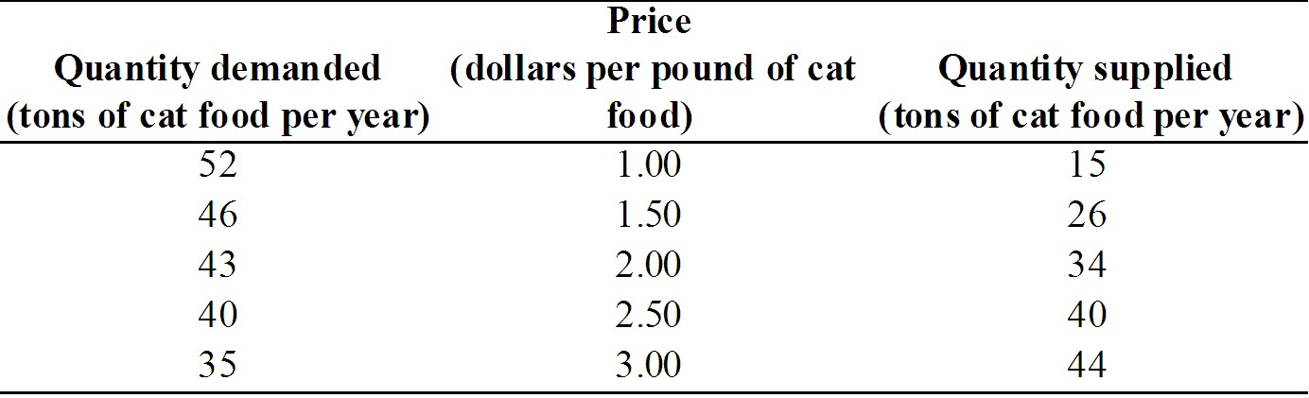

9)
The above table gives the demand and supply schedules for cat food. If the price is $3.00 per pound of cat food, will there be a shortage, a surplus, or is this price the equilibrium price? If there is a shortage, how much is the shortage? If there is a surplus, how much is the surplus? If $3.00 is the equilibrium price, what is the equilibrium quantity?
Topic:
Surplus
Skill:
Level 3: Using models
Section:
Checkpoint 4.3

10)
Consumers can use either natural gas or heating oil to warm their houses. Suppose the price of natural gas increases. Use a demand and supply diagram to show the impact of the higher price of natural gas on the market for home heating oil.
Topic:
Effects of a change in demand
Skill:
Level 3: Using models
Section:
Checkpoint 4.3

11)
In a diagram, illustrate the case of a price ceiling that affects the market's price and quantity.
Topic:
Price ceiling
Skill:
Level 3: Using models
Section:
Checkpoint 4.4

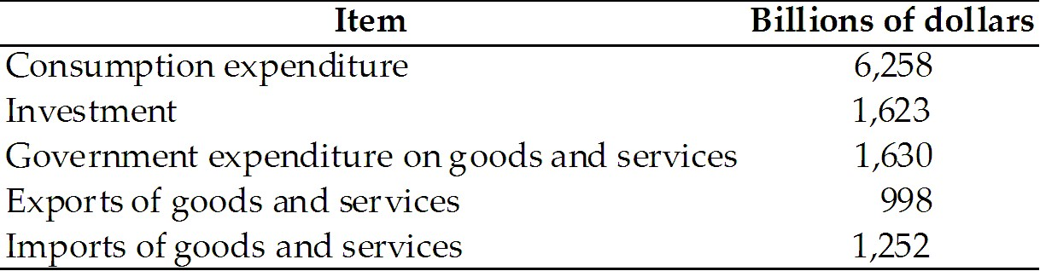

EXAM 2

12)
The table above gives the values of different expenditures in the United States during 1999. Answer the following questions about the United States.
a. What was the value of net exports of goods and services in 1999?
b. What was (nominal) GDP equal to in 1999?
c. What was the (nominal) value of total production equal to in 1999?
Topic:
Expenditure approach
Skill:
Level 3: Using models
Section:
Checkpoint 21

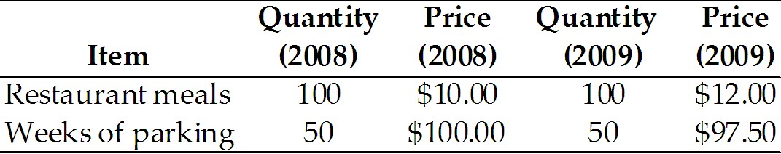

13)
The table above gives the purchases of a typical consumer in a country comprised of one large city. These consumers purchase only restaurant meals and parking. The year 2008 is the reference base period.
a. Find the total cost of the CPI market basket for 2008 and 2009.
b. What is the CPI in 2008 and in 2009?
c. What is the inflation rate between 2008 and 2009?
Topic:
Measuring the CPI
Skill:
Level 3: Using models
Section:
Checkpoint 22

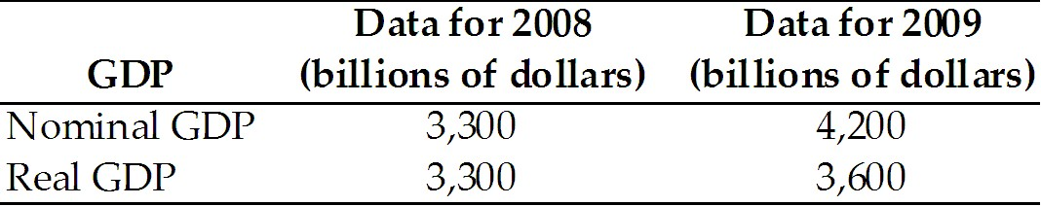

14)
The table above shows real and nominal GDP for two years.
a. What does the GDP deflator equal in 2008? What does the value of the GDP deflator tell you about 2008?
b. What does the GDP deflator equal in 2009?
Topic:
GDP price deflator
Skill:
Level 3: Using models
Section:
Checkpoint 22

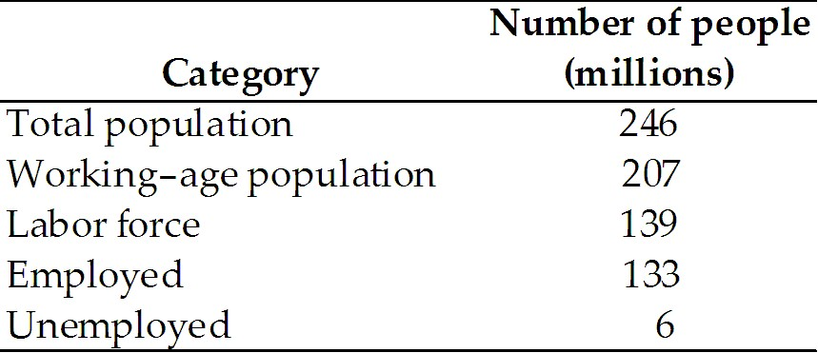

15)
Based on the information in the above table, what is the unemployment rate?
Topic:
Unemployment rate
Skill:
Level 3: Using models
Section:
Checkpoint 23

EXAM 3

16)
Canada's population is 31 million and Japan's population is 126 million. Labor productivity in the two nations is the same. Hence, real GDP per person is ________ and real GDP is ________.
A)
higher in Japan; larger in Japan
B)
higher in Japan; larger in Canada
C)
the same in Japan and Canada; larger in Japan
D)
higher in Japan; the same in Japan and Canada
E)
higher in Canada; larger in Canada
Topic:
Sources of economic growth
Skill:
Level 4: Applying models
Section:
Checkpoint 25

17)
If real income is above the subsistence level then, according to classical growth theory,
A)
the standard of living will continue to improve.
B)
the population will increase.
C)
more technological advances occur.
D)
labor productivity will increase.
E)
the population will decrease.
Topic:
Classical growth theory
Skill:
Level 2: Using definitions
Section:
Checkpoint 25

18)
The fastest growing nations today are those with
A)
the fastest growing exports and imports.
B)
government intervention in markets to ensure high prices.
C)
few funds spent on research and development.
D)
barriers that significantly limit international trade.
E)
the least saving.
Topic:
Policies for faster growth, international trade
Skill:
Level 2: Using definitions
Section:
Checkpoint 25

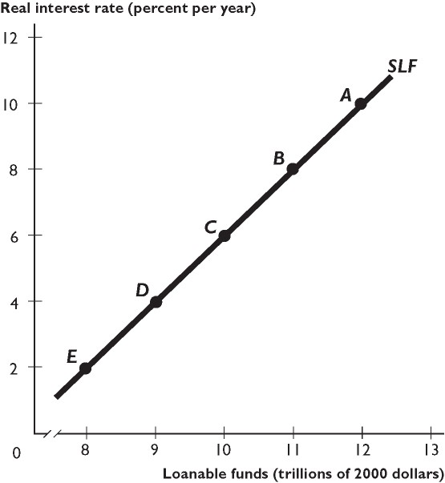
The figure above shows the supply of loanable funds curve.

19)
If the supply curve of loanable funds shifts rightward from the curve shown in the figure above, the shift could be the result of
A)
a decrease in the demand for loanable funds.
B)
a decrease in wealth.
C)
a decrease in the supply of loanable funds.
D)
a decrease in disposable income.
E)
a rise in expected future income.
Topic:
Supply of loanable funds curve
Skill:
Level 3: Using models
Section:
Checkpoint 26

20)
Suppose that there is an increase in disposable income and simultaneously an increase in the profitability of investment. As a result, the equilibrium real interest rate ________ and the equilibrium quantity of loanable funds ________.
A)
rises; increases
B)
might rise, fall, or remain unchanged; decreases
C)
falls; increases
D)
remains unchanged; increases
E)
might rise, fall, or remain unchanged; increases
Topic:
Loanable funds market equilibrium
Skill:
Level 4: Applying models
Section:
Checkpoint 26

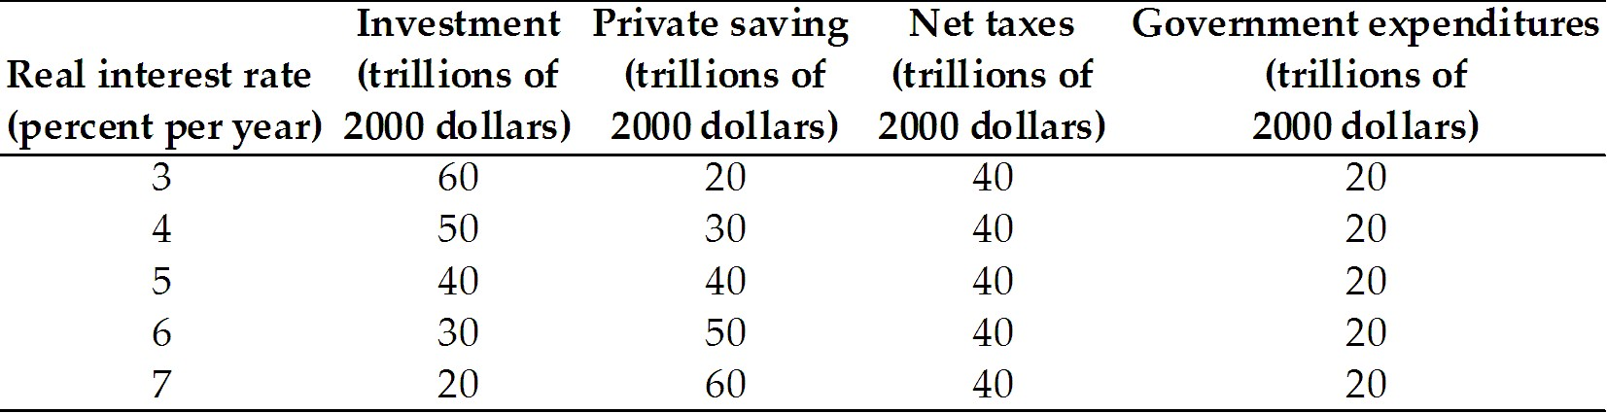

21)
The table above gives the investment demand and saving supply schedules for the world. It also has the government's net taxes and expenditures. The government has a budget
A)
deficit of $60 billion.
B)
surplus of $20 billion.
C)
surplus of $60 billion.
D)
surplus of $40 billion.
E)
deficit of $20 billion.
Topic:
Government saving
Skill:
Level 3: Using models
Section:
Checkpoint 26

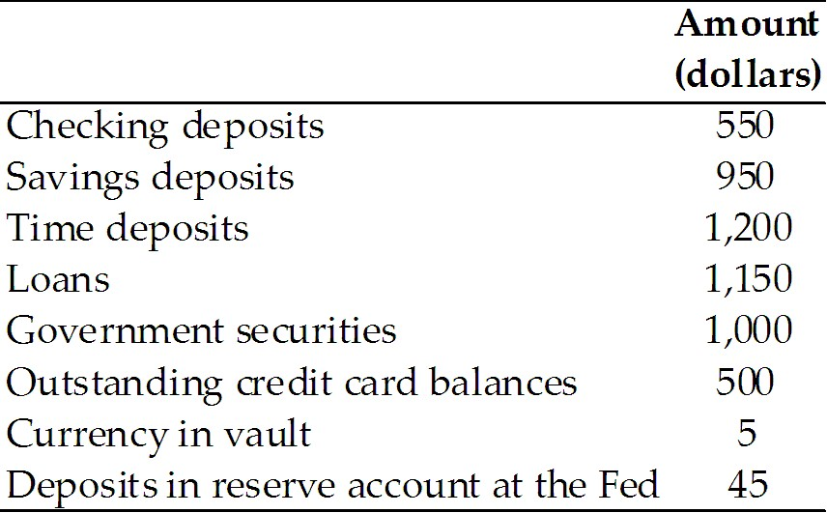

EXAM 4

22)
The above table gives assets and deposits for a (small) bank. The bank's deposits that are part of M2 are equal to
A)
$1650.
B)
$2150.
C)
$2,700.
D)
$1150.
E)
$550.
Topic:
Banks' deposits
Skill:
Level 3: Using models
Section:
Checkpoint 27

23)
A bank has checking deposits of $400, saving deposits of $900, time deposits of $900, loans of $950, government securities of $900, outstanding credit card balances of $400, currency in its vault of $40, and deposits in its reserve account at the Fed of $40.
a. What is the amount of this bank's deposits that are in M1?
b. What is the amount of this bank's deposits that are in M2?
c. What is the amount of this bank's reserves?
Topic:
Bank's balance sheet
Skill:
Level 3: Using models
Section:
Checkpoint 27

24)
The desired reserve ratio is 10 percent. Joe deposits $1,000 in Bank A. Bank A keeps its minimum desired reserves and lends the excess to Fred. Fred spends his loan at J.C. Penney. J.C. Penney deposits the check it receives from Fred in Bank B. Bank B keeps its minimum desired reserves and lends the excess to Mary. How much can Bank B lend to Mary?
A)
$810
B)
$100
C)
$90
D)
$1,000.
E)
$900
Topic:
Money creation
Skill:
Level 4: Applying models
Section:
Checkpoint 27

25)
How can a new deposit of $10,000 at one bank create other new deposits at other banks? Suppose the required reserve ratio is 10 percent and people keep no currency outside of the banks. What will be the new amount of deposits in the second and third rounds?
Topic:
The rounds of money creation
Skill:
Level 3: Using models
Section:
Checkpoint 27

26)
George purchased a $10,000 bond that pays a nominal interest rate of 8 percent per year. George's marginal income tax rate is 28 percent. Over the last year, inflation was 3 percent. Find George's before-tax real interest rate and his after-tax real interest rate.
Topic:
Cost of inflation, saving and investment
Skill:
Level 4: Applying models
Section:
Checkpoint 28

27)
State how each of the following affect the aggregate demand curve.
a. The price level increases.
b. Consumers expect higher inflation in the future.
c. The exchange rate rises.
d. Foreign income decreases.
Topic:
Changes in aggregate demand
Skill:
Level 2: Using definitions
Section:
Checkpoint 29

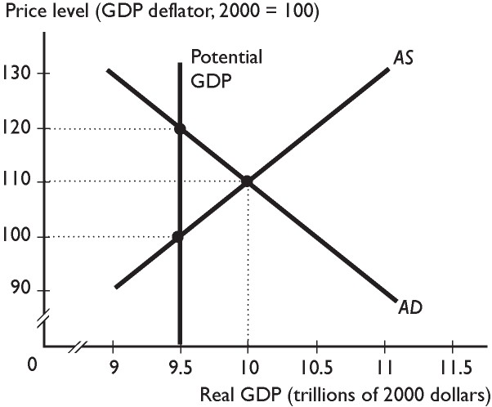
28)
What is the current equilibrium price level and real GDP for the economy illustrated in the figure above? Does this economy have an inflationary gap, a recessionary gap, or neither? As it adjusts toward full employment, which curve shifts? What is the equilibrium real GDP and price level that the economy will ultimately reach?
Topic:
Inflationary gap
Skill:
Level 4: Applying models
Section:
Checkpoint 29

1)
C
2)
D
3)
A
4)

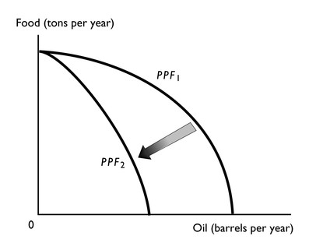
When a PPF is drawn, we draw it for a fixed amount of natural resources, along with fixed amounts of the other factors of production such as labor, capital, etc. Fire reduced Kuwait's natural resources temporarily, so the PPF after the war shifted inwards. However, because setting the oil wells on fire did not affect Kuwait's ability to produce food, the maximum amount of food production, the point where the PPF intersects the vertical axis, did not change.
5)

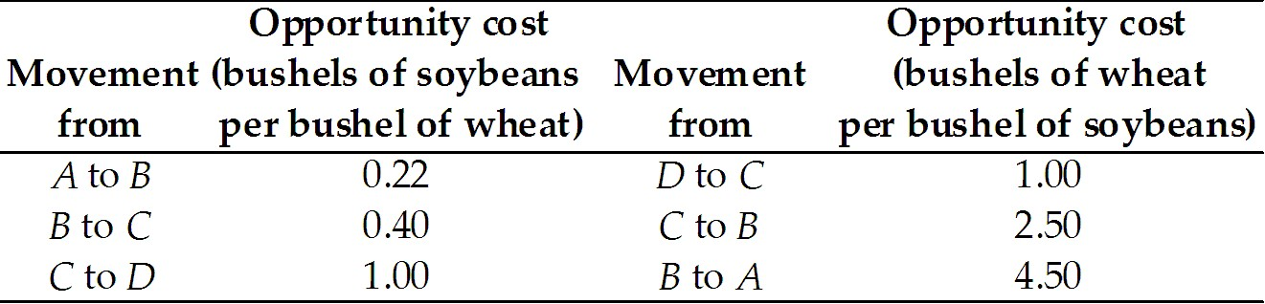

The table above gives the opportunity costs. The units of the opportunity costs are in the column headings.
6)
a. Omar has an absolute advantage in fixing computers and writing code because he can fix 12 per day compared to John who can fix only 4 per day, and can write 800 lines of code per day compared to John who can write only 200 lines a day.
b. John has the comparative advantage in fixing computers. He has the comparative advantage because his opportunity cost of fixing one computer is 50 lines of computer code. Omar does not have a comparative advantage in fixing computers because his opportunity cost of fixing a computer is higher at 66.7 lines of code.
c. Omar has the comparative advantage in writing programs. His opportunity cost of writing one line of code is .015 of a computer fixed. John does not have the comparative advantage in writing programs because his opportunity cost of writing one line of code is 0.02 computers fixed. (Alternatively, to write 1 line of code costs Omar the opportunity to repair 1.5 percent of a computer and costs John the opportunity to repair 2.0 percent of a computer.)
7)

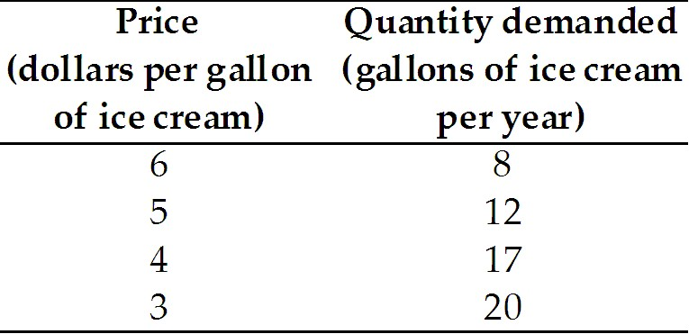

8)

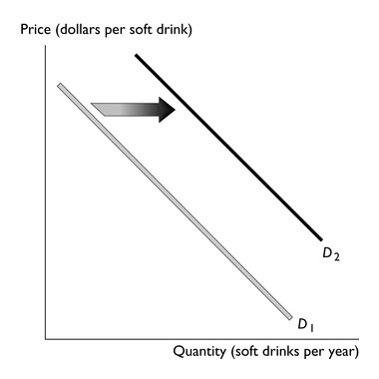
9)
At a price of $3.00 per pound of cat food, there is a surplus. The surplus equals 44 tons (the quantity supplied) minus 35 tons (the quantity demanded), or 9 tons of cat food.
10)

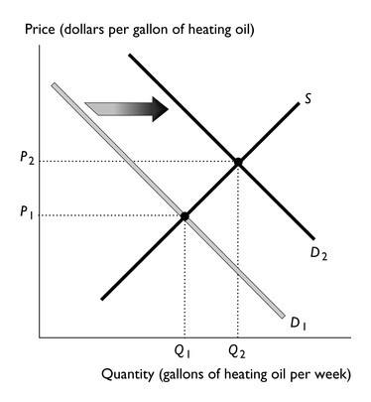
11)

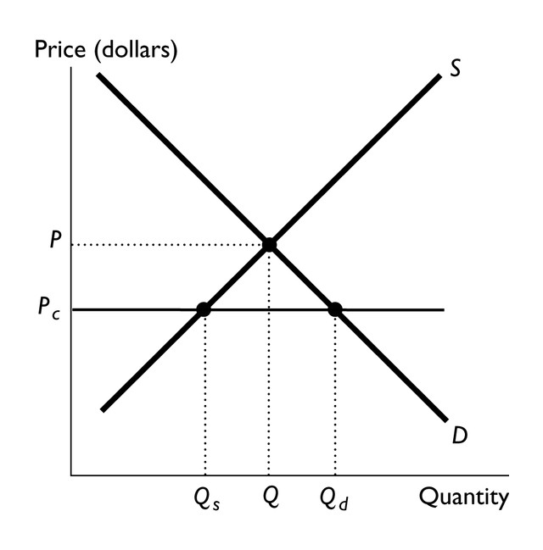
The figure above has a price ceiling, Pc , that is set below the equilibrium price, P. As a result, a shortage equal to Qd - Qs emerges.
12)
a. Net exports of goods and services equals the value of exports of goods and services, $998 billion, minus the value of imports of goods and services, $1,252 billion, or -$254 billion.
b. GDP equals the sum of consumption expenditure, $6,258, plus investment, $1,623, plus government expenditure on goods and services, $1,630, plus net exports, -$254, or $9,257 billion.
c. The value of total production equals the value of GDP, so total production was $9,257 billion in 1999.
13)
a. The total cost of the CPI market basket in 2008 equals (100 meals × $10) + (50 parking × $100) = $6,000. The total cost of the CPI market basket in 2009 equals (100 meals × $12) + (50 parking × $97.50) = $6,075. The quantities are the same in 2008 and 2009. If the quantities differed, the 2008 quantities would be used because 2008 is the base year.
b. The CPI in 2008 is 100 because 2008 is the base period. (Alternatively, the CPI in 2008 equals 100 × ($6,000)/$6,000) = 100.) The CPI in 2009 equals 100 × ($6075)/($6,000) = 101.25.
c. The inflation rate between 2008 and 2009 equals 100 × (101.25 - 100)/(100) = 1.25 percent.
14)
a. The GDP deflator equals (100) × (nominal GDP ÷ real GDP). In 2008, the GDP deflator equals (100) × ($3,300 trillion ÷ $3,300 trillion) = 100. Because the GDP deflator equals 100, we can determine that 2008 is a base year.
b. In 2009, the GDP deflator equals (100) × ($4,200 ÷ $3,600) = 116.67.
15)
The unemployment rate equals (6 million unemployed ÷ 139 million labor force) × 100 = 4.3 percent.
16)
C
17)
B
18)
A
19)
B
20)
E
21)
B
22)
C
23)
a. The only deposit that is in M1 is the checking deposits, so the amount of this bank's deposits that are in M1 is $400.
b. Deposits in M2 include checking deposits, saving deposits, and time deposits. Therefore the amount of this bank's deposits that are in M2 equals $400 + $900 + $900 = $2,200.
c. Reserves are the sum of the currency in the bank's vault plus its deposits in its reserve account at the Fed. Therefore the bank's reserves are $40 + $40 = $80.
24)
A
25)
When the bank receives a new deposit of $10,000, it will loan some of the deposit. The proceeds of the loan will be deposited in another bank, which will then loan some of its new deposits. Hence an initial deposit at one bank leads to deposits at other banks.
With the required reserve ratio of 10 percent, the first bank must keep $1,000 as reserves (10 percent of $10,000) and it can loan the remainder, $9,000. Thus the deposit at the second round bank will be $9,000. The second round bank must keep $900 as reserves (10 percent of $9,000) and can loan the remainder, $8,100. The deposit in the third round bank will be $8,100.
26)
The before-tax interest rate equals the nominal interest rate minus the inflation rate, or 8 percent - 3 percent = 5 percent. For the after-tax real interest rate, note that George must pay tax on the entire 8 percent (nominal) interest. Hence George pays (8 percent interest rate × 28 percent tax rate) = 2.24 percent as taxes. Therefore his after-tax real interest rate equals his before-tax real interest rate, 5 percent, minus what he pays in taxes, or 5 percent - 2.24 percent = 2.76 percent as his after-tax real interest rate.
27)
a. There is a movement upward along the aggregate demand curve. The aggregate demand curve does not shift.
b. The aggregate demand curve shifts rightward.
c. The aggregate demand curve shifts leftward.
d. The aggregate demand curve shifts leftward.
28)
The equilibrium is where the aggregate demand and aggregate supply curves intersect. Thus the equilibrium price level is 110 and equilibrium real GDP is $10 trillion. Real GDP exceeds potential GDP, so the economy has an inflationary gap. The aggregate supply curve will shift leftward as the economy adjusts to full employment. Ultimately the aggregate supply curve will shift so that it intersects the aggregate demand curve where the aggregate demand curve crosses the potential GDP line. Thus ultimately equilibrium real GDP equals potential GDP, $9.5 trillion, and the price level is 120.

