
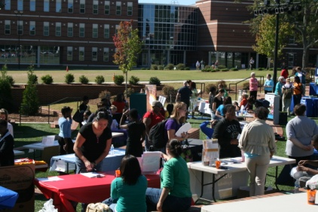
October 14
D. Douglas Barnard Amphitheater

This is a great opportunity for you to get involved in the community and find out where you can help! Volunteering can be a rewarding experience that will also look great on a resume!
Helping someone else can take as little as 10 minutes! Come find out how you can Get Involved!
11 AM- 1 PM


For more information or to request a table for your campus organization:
706-737-1604
www.aug.edu/career_center
careercenter@aug.edu
Boykin Wright Hall, 2nd Floor

Brought to you by:

