MINF3650 TechPrac14
I Business Process Diagraming Review the Wikipedia article on Event-driven process chain diagrams plus some (not all that informative but get's you started) documentation on developing EPC diagrams using Visio.
- (10 pts) Use Microsoft Visio to duplicate the following Event-driven process chain diagram. Name the Visio tab ExampleEPC and name the Visio file EPC.vsd.
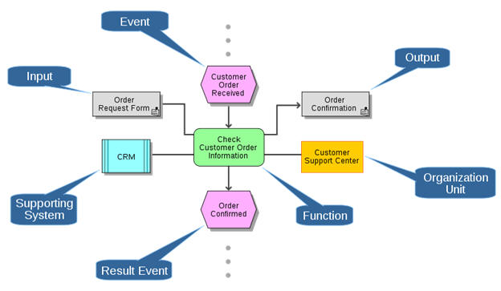
- (40 pts) On a second tab in the Visio file named JobSearch, create an EPC diagram which describes how you would go about searching for a career related job after graduation. Key functions should be preparation of resume and one of the resulting events position accepted/declined. Save the file and submit it through your online lab.

