MINF3650 TechPrac05
I (25 pts) Create and work with a small database
- Review the DB Build Video from class
- This video introduced an 'accelerated reader' system with the following data model
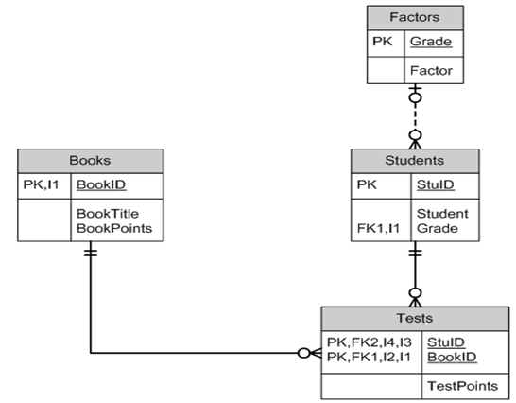
and the following data in third normal form
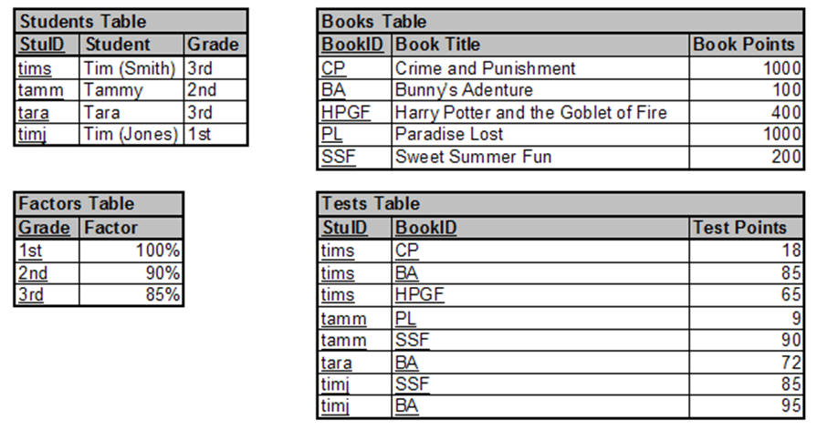
- Create an Access database named AccRdr.accdb which implements this data model (tables, columns, and relationships).
- Populate your database with the sample data but in addition
    - Add a 13th grade to the Factors table with a factor of 25%;
    - Add yourself to the Students table (make up a unique StuID and you are in the 13th grade);
    - Add a book you like to the Books table (make up a book id and its points are equal to 1000 plus the last 3 digits of your 927 number);
    - Add a test which you took on the book you added. Your TestPoints were the 5th & 6th digits of your 927 number.
- Create a query named AllTests which reproduces the information (though not the format) of the following slide from the walkthru (i.e., list all students, their grade, the grade factor, books they have tested on, the book points, the test points, and the points earned).
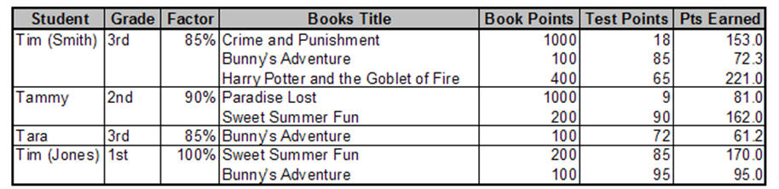
- Beyond the video: Create a query named BooksByGrade which lists Grade and any Books (by titles) read by a student in that grade (presumably for a report showing what has been read by grade).
- Beyond the video: Create a query named StudentSummary which shows each student (who has taken at least one test) and the total Pts Earned by that student. Hint: Use the AllTests query as input, keep only the Student and Pts Earned columns, and make it a summary query where you Group By Student and Sum Pts Earned.
- Attach the completed AccRdr.accdb database to this assignment for grading (note that one consolidated database from both I & II should be prepared).
II (25 pts) Develop basic database forms and reports
- Continue with the AccRdr.accdb created in item I above in which you created an 'accelerated reader' database from a data model.
- Create a form named frmBooks which allows entry, update, & delete of information in the Books table.
- Create a form named frmStudents which allows entry, update, & delete of information in the Students table.
- Create a form named frmStudentTests which shows each student and, for each student, a list of the books on which they have been tested.
- Create a report named rptStudentTotals which has a group for each student. The group header should show student information and within the group should be a list of the books they have read including the Pts Earned for the book. At the end of the group should be a sub-total of the total Pts Earned for the student.
- Attach the completed AccRdr.accdb database to this assignment for grading (note that one consolidated database from both I & II should be prepared).

Submit ONE Database through submissions in online lab.

