MINF2201: REQUIRED RESOURCES
Course Material List
Required Materials: | Hardware: | - Windows OS based Computer with high speed internet access (or access to one)  *Mac Users review Mac Requirement Webpage. *Chromebooks are not compatible.
Required Materials: | Hardware: | - Personal Thumb Drive (students are not to share)
Required Materials: | Hardware: | - Ear buds (needed for learning aid and chapter video sound in campus labs)
Required Materials: | Software: | - Pearson MyITLab Access Code (www.mypearsonlab.com)
Required Materials: | Software: | - Microsoft Office 2013 365 or Professional Pro (available at no charge through GRU)
Required Materials: | Software: | - Google Chrome or FireFox (Free Downloads available) Do Not Use Safari or Explorer.
Required Materials: | Text: | - REQUIRED: Go! with Office 2013 Gaskin, Vargas, McLellan. Volume 1 ISBN(13): 9780133142662
Required Materials: | Text: | - REQUIRED: Technology In Action Evans, Martin, Poatsy. 11th ed. ISBN(13): 9780133802962
Course Resources: | Instructor Website: | http://spots.gru.edu/bschmidt
Course Resources: | Online Lab: | www.mypearsonlabs.com
Course Resources: | Professor: | Email, Text, or Meeting. See Contact Prof Schmidt or Online Support webpages
JAG STORE OPTIONS
OPTION #1: $223  - Both e-texts  - Both Physical texts  - Pearson Access Code  - New Ear Buds  - New Thumb Drive | 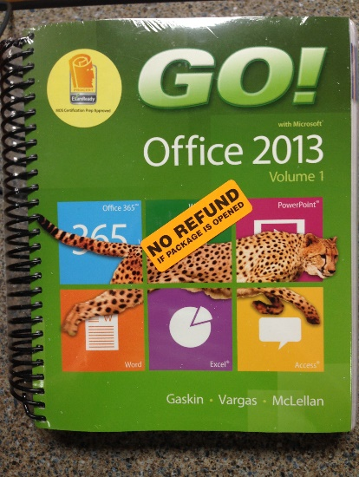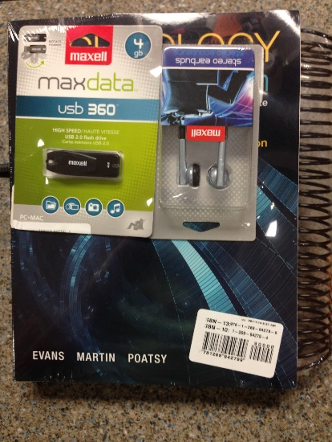  Visit Prof. Schmidt’s MINF2201 Required Resource Webpage for More Details including TIPS ON SAVINGS and Getting Started WITHOUT FINANCIAL AID!  *ACCESS to the INTERNET (with decent Connection Speed) IS REQUIRED!
OPTION #2: $151  - Both e-texts  - Pearson Access Code  - New Ear Buds  - New Thumb Drive | 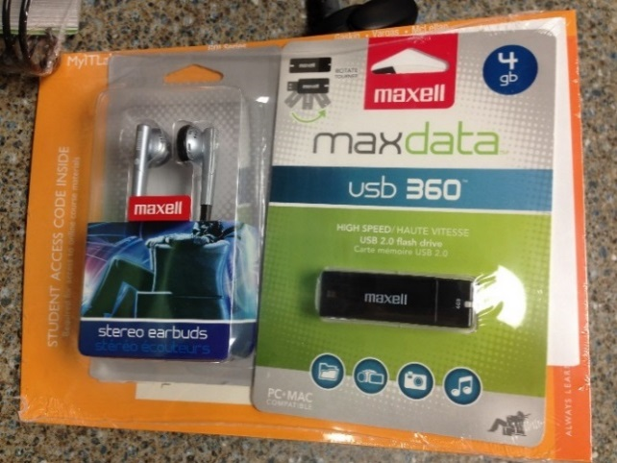
NON-JAG STORE OPTIONS
NON-JAGSTORE OPTION: $120  - Both e-texts  - Pearson Access Code  - Option to purchase hole punched text for $35 | - Go to www.mypearsonlab.com  - Purchase Online Lab Access while registering in the course*  (*or before the 17 day Free Trial Period runs out)  - Click on MINF2201 Course  - Click on Course Materials  - Click on e-text  - Click on Go! with MS Office 2013, Volume 1 Print Upgrade  - Enter Credit Card and other requested information.
DO NOT PURCHASE AN ONLINE PURCHASE OPTION WITHOUT THE E-TEXTS!

