The Changing Effectiveness of Key Policy Tools in Thailand

Final Report

Submitted to

East Asian Development Network

From Yonok Research Institute

Yonok Research Institute Principal Investigator:
Yonok College Jonathan E. Leightner, Ph.D.
Lampang, Thailand 52000 College of Business Administration
Tel. (054) 265-170-6 Augusta State University
Fax. (054) 265-184 Augusta, GA 30904-2200 USA
E-mail: paitoon@star.yonok.ac.th E-mail: jleightn@aug.edu

Abstract

A new analytical technique (Reiterative Truncated Projected Least Squares: RTPLS) is developed, explained, and tested. Simulation tests indicate that RTPLS is far superior to Ordinary Least Squares (OLS) when omitted variables interact with included variables. RTPLS is used to derive fiscal and monetary multipliers for Thailand both before and after the floating of the Thai Baht. The average government spending multiplier was 3 and the average money supply multiplier was 0.75 prior to the floating of the baht. However, the government spending multiplier declined by 74 percent after Thailand floated the baht and the money supply multiplier fell by 63 percent at the same time. The effectiveness of three monetary policy tools also are tested. After the crisis, both open market operations and Bank of Thailand loans to commercial banks are ineffective tools. The effectiveness of reserve requirements fell drastically after the crisis and became less stable.

April 26, 2002

The Changing Effectiveness of Key Policy Tools in Thailand

I. Introduction

The purpose of this study is to test the hypothesis that after Thailand floated its currency on July 2, 1997, the effectiveness of Thailand’s monetary and fiscal policies declined. To test this hypothesis, this report will provide estimates of Thailand’s government spending and money supply multipliers both before and after the floating of the Thai currency, the baht. If either the numerical value of a multiplier fell or if it became less stable (its variance rose) after the floating of the Thai baht, then this will provide evidence for the hypothesis. Additionally, the estimates of government policy multipliers should help Thai government officials predict the effects of proposed changes in government spending and the money supply, which should give them more control over the Thai economy.
In order to correctly estimate government policy multipliers for Thailand, the influence of numerous variables that interact with government policy must be incorporated into the estimation procedure. Incorporating these variables into the model is particularly difficult for the Thai case because these variables include some immeasurable forces, like (1) a self-reinforcing increase in property values leading to a speculative bubble, (2) rising then plummeting international expectations, (3) re-contagion effects as Thailand’s financial crisis spread throughout Asia and even to Brazil and Russia, which further diminished international expectations for Thailand, (4) escalating fear in the banking sector of increased competition prior to the crisis which turned into fear of government take over after the crisis, and (5) a drying up of credit in the wake of the crisis and the strategic non-payment of loans [see: Leightner (forthcoming, 2000, 1999a, 1999b), Leightner and Alam (forthcoming), and Leightner and Lovell (1998)].
Building on Branson and Lovell (2000), the principal investigator of this study created a new analytical technique named Reiterative Truncated Projected Least Squares (RTPLS) that produces reduced form estimations while greatly reducing the influence of omitted, unknown, and immeasurable variables. This new technique makes it possible to estimate government policy multipliers that reflect the influence of the numerous variables that interact with government policy without having to measure these variables and without having to even know what these variables are.
The first stage of RTPLS is Two Stage Least Squares (2SLS), where the first stage is replaced by an output oriented frontier analysis (or data envelopment analysis – DEA). By projecting all data to this frontier, the influence of unfavorable omitted variables is eliminated. The second stage regression then estimates the relationship between the dependant variable and the included variable when the omitted variables are at their most favorable level. Before the next RTPLS iteration is conducted, the observations that determined the frontier in the previous iteration are eliminated. Additional iterations are conducted until the sample size is too small to support an additional iteration. Each iteration produces a slope estimate of the relationship between the dependant and included variable under progressively less favorable levels of omitted variables. A given iteration’s slope estimate is entered into the data for the observations that determined the frontier in that iteration. A final regression is then conducted between these slope estimates and a constant, the inverse of the included independent variable, and the ratio of the dependant variable to the included independent variable. The data is then plugged back into the equation estimated in this final regression in order to determine a slope estimate for each observation. These slope estimates are reduced form estimates that capture the influence of everything that is correlated with the included variables.
The results of the first 30 simulation tests of RTPLS indicate that OLS produces an average of 125 percent more error than RTPLS when omitted variables cause the true coefficient for the included variable to vary by ten percent. When the omitted variables cause the true coefficient to vary by a hundred and a thousand percent, then OLS produces an average of 112 percent and 401 percent (respectively) more error than RTPLS. RTPLS produces reduced form coefficients that capture all the forces correlated with the included variable without having to construct complicated systems of hundreds or thousands of equations.
The remainder of this report is organized as follows. In Section 2, the principal findings of this study are presented in the context of the literature on Thai government policy multipliers. Section 3 explains the analytical techniques used to eliminate the influence of omitted variables and to calculate the multipliers and elasticities presented in Sections 2 and 5. In Section 4, the Thai data and the specific equations used to analyze the Thai case are discussed. In Section 5, multipliers for the relationship between the money supply and three monetary policy tools -- open market operations, central bank loans to commercial banks, and reserve ratios -- are estimated. The effectiveness of all three tools fell noticeably after the crisis. Section 6 briefly discusses monetary policy in Thailand. Section 7 provides a conclusion.

II Principal Findings in the Context of the Literature

This study’s primary findings are presented in Table 1 and graphically depicted in Figures 1-4. The government spending multiplier is approximately 3.65 in January 1993 and gradually falls to 2.52 in November 1995. It then fluctuates between 2.51 and 2.86 between November 1995 and June 1997. The June 1997 multiplier of 2.76 means that if the Thai government had spent an additional million baht in that month, then Gross Domestic Product (GDP) would have gone up by 2.76 million baht. Why there is a multiplier effect can be seen by considering an example. If the Thai government builds a road, it must pay the road builders. The road builders spend part of their pay on food. The food growers spend part of their income on a tractor and this process continues. The road, the food, and the tractor are all part of GDP; thus, GDP goes up by more than just the amount paid for the road. A government multiplier of approximately 3 is reasonable for a country like Thailand during its period of exceptional economic boom (Bhongmakapat, 2001).
Column 5 of Table 1 shows that the government spending multiplier fell from 2.76 in June of 1997 to 0.96 in July and kept falling till it hit 0.17 in September of 1997. Thailand floated its currency, the baht, on July 2, 1997. Figure 1 shows that after September 1997, the value for the government spending multiplier fluctuated widely (before variance = 0.09, after variance = 0.35). On average, the government spending multiplier after July 1997 is 74 percent lower than the average multiplier before the crisis. This means that a given increase in government spending will produce 74 percent less of an increase in GDP after
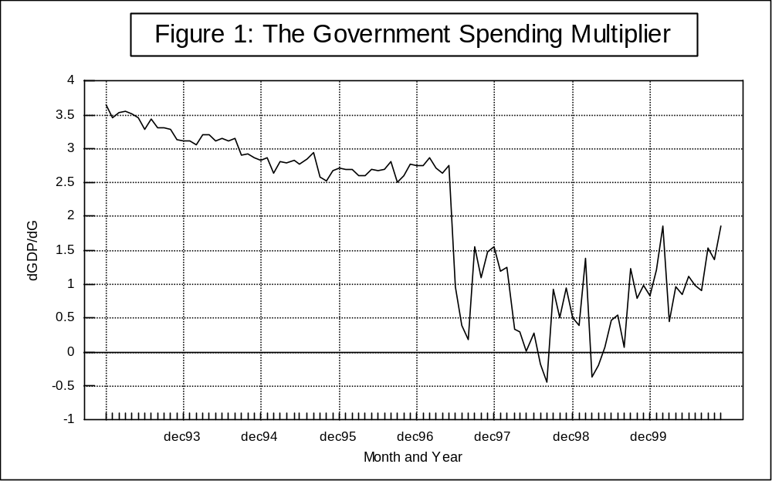
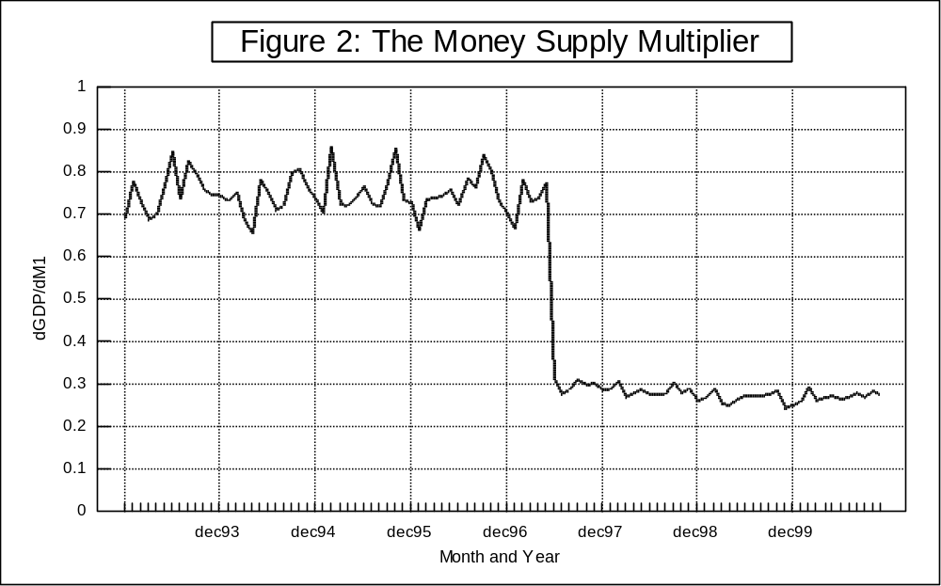

the crisis than it did before the crisis. However, the December 2000 multiplier of 1.86 is only 33 percent lower than the June 1997 multiplier of 2.76. Since both the numerical value and the stability of the government spending multiplier fell after the floating of the Thai baht, the effectiveness of government spending as a policy tool declined after the floating of the baht.
The analytical technique used in this paper makes it possible to trace out how the government spending multiplier is changing over time due to the influence of forces not directly modeled. In contrast, other studies that estimate government spending multipliers produce only one estimate for the entire time period studied. For example, the Bank of Thailand’s macroeconomic model produces a government spending multiplier of approximately one; however, if all imports are excluded from additional government spending then this multiplier could be as high as 1.9, and if commercial banks could resume their normal lending, then this multiplier could be even higher (Bank of Thailand, 2001, p. 16). In a private interview, Atchana Waiquamdee admitted that the Bank of Thailand’s model is unstable – every time additional data is added to the model, many estimated coefficients change drastically (Waiquamdee, 2001). In order to stabilize the Bank of Thailand’s model, many dummy variables have been added. The Bank of Thailand’s model is based on quarterly data from 1993 to 2000, consists of 38 equations with 29 (non-dummy) exogenous variables and 17 dummy variables.
The Thai Development and Research Institute (TDRI) also has conducted two studies that estimate a government spending multiplier for Thailand. In a study conducted for the Bureau of the Budget, TDRI constructed a Social Accounting Matrix (SAM) for Thailand in 1995 which included 109 accounts, including 76 sectors of production and 20 household types separated by income deciles and whether the household’s main occupation was in agriculture or non-agriculture (Sussangkarn and Tinakorn,1998). TDRI used the Fixed Price Multiplier analysis explained by Pyatt and Round (1979). Using this framework, the GDP multiplier for government expenditure is about 0.99. In an updated analysis, which is not yet published, Chalongphob Sussangkarn constructs a similar SAM for the year 2000 and finds a government expenditure multiplier of approximately 0.91. In another study conducted for the Bureau of the Budget, TDRI constructed a macro-econometric model for Thailand using annual data and found a government spending multiplier of 0.88 (Tinakorn and Sussangkarn, 2001).
Most studies of government policy multipliers are produced by central banks for internal use only. The studies cited above were found via contacts through the Bank of Thailand and through the East Asian Development Network. A more traditional search of the literature produced no published money supply multipliers for Thailand and no published studies of government spending or money supply multipliers for other crisis-hit countries.
Column 6 of Table 1 and Figure 2 show the estimates of the money supply multiplier produced by this study. The pre-crisis average money supply multiplier of 0.75 (penultimate row of Table 1) implies that if the Bank of Thailand had increased the money supply by 1 million baht prior to the crisis, then GDP would have increased by 0.75 million baht; in contrast, after the floating of the baht, the same increase in the money supply would have only increased GDP by 0.28 million. In contrast to the government spending multiplier, the money supply multiplier appears to be more stable after the floating of the baht than before the floating (before variance = 0.00212, after variance = 0.00024). However, since the magnitude of both fiscal and monetary policy multipliers were drastically reduced after the floating of the baht, these policy tools became less effective.
Columns 7 and 8 of Table 1 and Figures 3 and 4 show the inflation elasticities for government spending and the money supply. The average pre-crisis government spending inflation elasticity of 0.202 (penultimate row of Table 1) implies that a one percent increase in government spending would have caused a 0.202 percent rise in the consumer price index prior to the crisis. In contrast, after the crisis, a one percent increase in government spending would have caused the consumer price index to increase by only 0.025 percent. Although multipliers and elasticities, like those reported in Table 1, are most accurate for small changes in government spending or the money supply, it is probably safe to say that a doubling of government spending would have cause the consumer price index to increase by at least 20.2 percent prior to the crisis and by at least 2.5 percent after the crisis.
Figure 3 shows that the government spending inflation elasticity varied significantly prior to the crisis. This variation is not unexpected since the amount of inflation a given change in government spending would cause is strongly affected by the current levels of consumption and investment. In this case, consumption and investment are two of the omitted variables accounted for by this study’s new statistical methodology, without having to create a complicated model of all the interactions between government spending, consumption, and investment.
Figure 4 and Column 8 of Table 1 show that the money supply inflation elasticity steadily increased from 0.271 in January 1993 to 0.461 in June 1997. This June 1997 inflation elasticity implies that a one percent increase in the money supply in that month
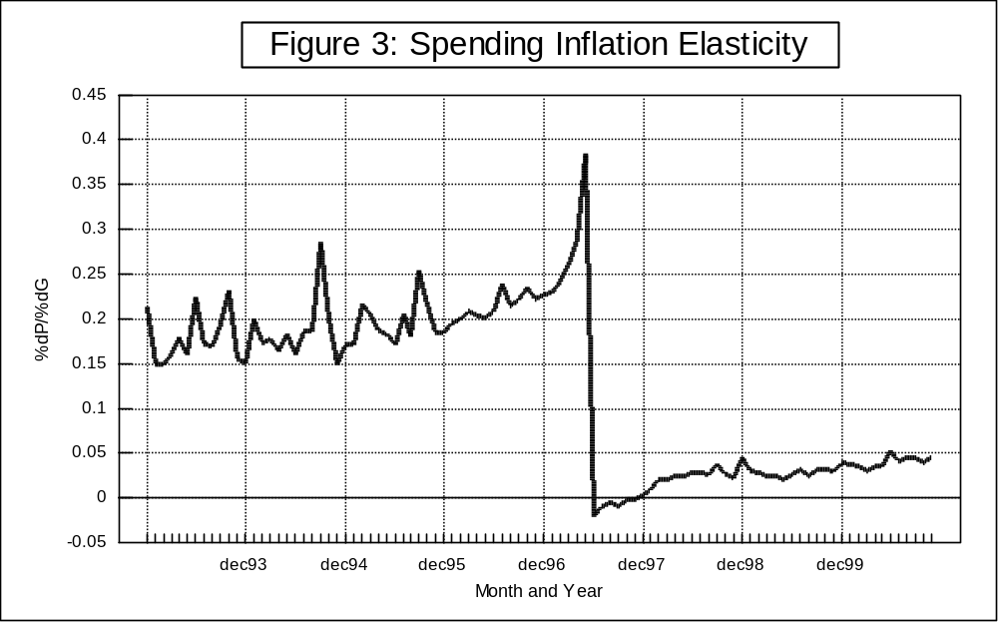

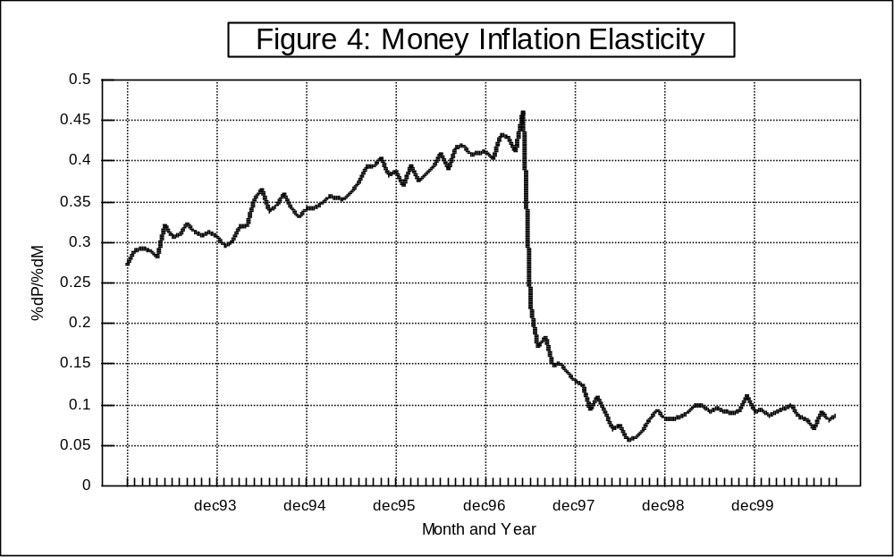

would have caused the consumer price index to increase by 0.461 percent. The money supply inflation elasticity fell from 0.461 in June 1997 to 0.222 in July 1997and kept falling till it hit a low of 0.057 in August 1998.
A search of the literature produced only three studies that reported estimates of government spending multipliers for Thailand, no studies that reported money supply multipliers, and no studies that provided inflation elasticities for government policies. Furthermore, no studies were found of government policy multipliers for other crisis-hit countries. This lack of literature is partially due to central banks conducting their own studies for internal use, and not for publication. Unlike the methodologies currently used by central banks and research institutes, the analytical technique used in this study makes it possible to trace out how the effects of government policy on GDP and inflation change over time due to unknown, immeasurable, and omitted variables. Furthermore, the analytical technique used here does not require the construction of complicated macro-econometric models or social accounting matrixes. Finally, this study’s principal findings strongly support the hypothesis that after the floating of the Thai baht, the effectiveness of government policy has fundamentally changed in Thailand.

III Analytical Techniques:

The analytical technique used in this paper is built upon a technique introduced by Branson and Lovell (2000). The Branson--Lovell method is similar to an instrumental variables method, like two stage least squares (2SLS), which is used to correct for simultaneous equation bias. In the 2SLS method, all endogenous variables are regressed on all exogenous variables. Instruments for the endogenous variables are then constructed by projecting the endogenous variables to the resulting regression line. The instruments are then used to estimate the desired equation. In essence, 2SLS throws away all the variation in the endogenous variables that cannot be explained by the exogenous variables.
The Branson--Lovell method replaces the first stage in 2SLS with a linear programming data envelopment analysis (DEA), which constructs a best practice frontier. This best practice frontier shows the relationships between the dependent variable and the included independent variables when the omitted variables are at their most favorable levels. All observations are then projected to this frontier, thus purging from the data the variation caused by the omitted variables. The projected data points are then used to estimate the desired equation. For purposes of clarification, the Branson--Lovell method will be called “Projected Least Squares” (PLS) in this study.
Whereas OLS places a line through the middle of the data, DEA draws a facetted envelope around the top of the data by drawing a line between the best-practice observations. Best-practice is defined as those observations that produce the most output (dependent variable) for a given level of inputs (independent variables) or uses the least inputs for a given level of output. In most previous applications of DEA, the distance an observation falls below (or to the right of) this frontier is a measure of inefficiency. OLS assumes that all the variation from the OLS line is random error, and DEA typically assumes that all the variation from the DEA frontier is inefficiency.
The first stage of Projected Least Squares (PLS) gives a new interpretation to the distance between the DEA frontier and a given observation. Under PLS, an observation falls below the best practice frontier if unfavorable omitted variables have affected that observation. The ratio of maximally expanded output production to actual output production (Φ) provides a measure of the influence of unfavorable omitted variables on each observation.
Denote the outputs (or dependant variable) of an observation by y_{im}, i=1,..., I, m=1,...,M and the inputs (or independent variables) of an observation by x_{in}, i=1,...,I, n=1,...,N. Consider the following DEA problem:

(1) Objective: max Φ
subject to Σ_{i} λ_{i} x_{ni} < x_{n}º , n = 1,..., N
Φy_{m}º < Σ_{i} λ_{i} y_{mi} , m = 1,...,M
Σ_{i} λ_{i} = 1; λ_{i} >0, i=1,...,I .
This problem is solved I times, once for each observation in the sample. For observation "o" under evaluation, the problem seeks the maximum radial expansion in all outputs y_{m}º consistent with best practice observed in the sample, i.e., subject to the constraints in the problem.
The first stage of PLS calculates this best practice frontier between the output (dependent variable) and inputs (independent variables) and then projects each observation to the frontier by multiplying actual output by Φ, the measure of the influence of unfavorable omitted variables. By projecting the data to the frontier, the influence of unfavorable omitted variables is eliminated.
In order to test PLS, three series of one hundred random numbers each were computer generated. The values of these random numbers range between zero and one thousand. The three data series are shown in the first three columns of Table 2 and are labeled X₁, X₂, and X₃. The fourth column of Table 2 shows Y₁, which was constructed via the equation Y₁ = 50 + X₁ + 2 X₂. The first six columns of Table 2 were generated and then the rows of this table were sorted by the increasing numerical value of column 1.
Figure 5 plots the relationship between Y₁ and X₁. Each point on Figure 5 is identified by the corresponding value for X₂. Notice that the lower, right hand envelope of the points in Figure 5 correspond to the smallest values of X₂. Notice also that the upper, left hand envelope of the points in Figure 5 correspond to the largest values of X₂. Figure 5 shows that, as one moves from the lower to the higher parts of this figure, the true relationship between Y₁ and X₁ is being shifted up by increasing values of X₂.
When the analytical techniques described above are applied to this data, they construct a best practice frontier consisting of the left handed and upper envelopes of this data. Column 5 of Table 2 shows the omitted variables scores (Φ), which will be multiplied by Y₁ in order to project the data to the frontier. Figure 6 shows the data after the dependent variable has been projected to the frontier. The upper portion of this frontier shows the relationship between X₁ and Y_{1,} when X₂ is held relatively constant at its highest values. The second stage of PLS then uses the projected data points in a regression to estimate the true relationship between X₁ and Y₁.
The upper part of Figure 6's frontier is extremely close to the true relationship between X₁ and Y₁ (when X₂ is at its highest level). In contrast, the three points that make up the left hand section of this frontier have nothing to do with the true relationship between X₁ and Y₁ (when X₂ is at its highest level). From where did these three points come? The data in Figure 5 actually correspond to 100 lines showing the true relationship between X₁ and Y₁, one for each separate value of X₂. If these lines are like one hundred
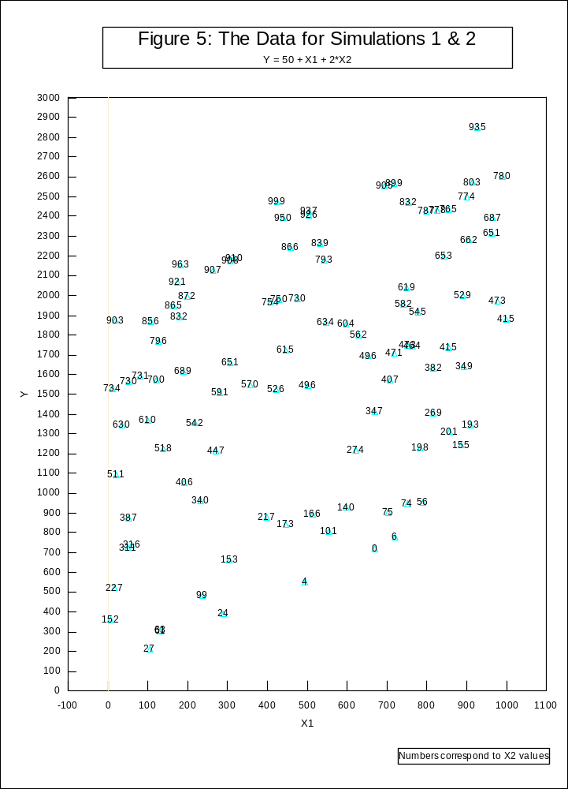
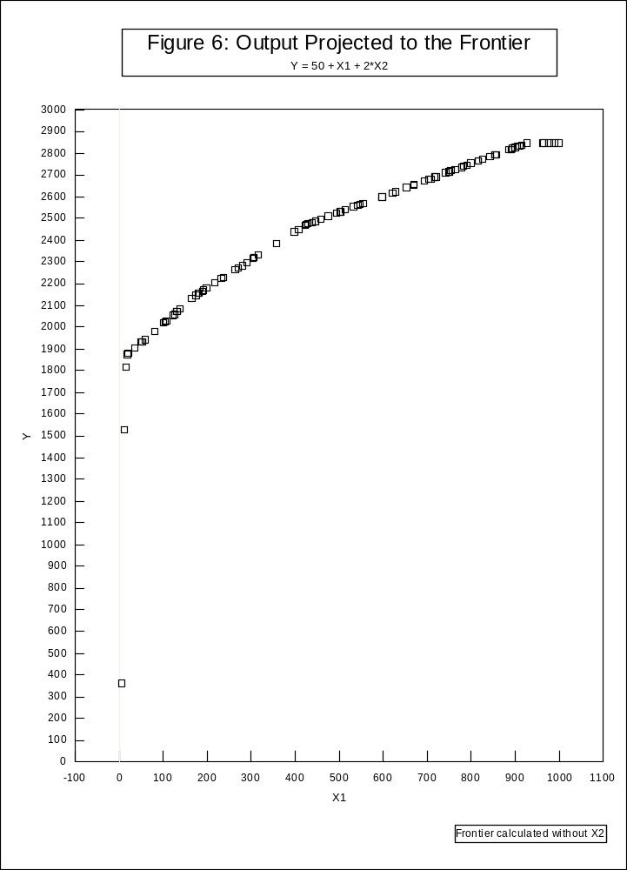
parallel grain lines in a piece of wood, then the three points in the lower left side of Figure 6 are the smallest values for the end-grain of that wood. For PLS to work as well as possible, these three points must be eliminated before the second stage regression is conducted. “Projected Least Squares” (PLS) does not eliminate end-grain observations but “Truncated Projected Least Squares” (TPLS) does eliminate end-grain observations.
It is possible to have end-grain observations at both ends of the frontier. By looking at Figure 6, a researcher can tell that it is extremely likely that the three points which correspond to the smallest values of Y₁ are from end-grain observations. Column 6 of Table 2 shows the Y₁ values after they are projected to the frontier. In order to better show the end-grain observations, the rows of Table 2 were sorted by increasing numerical value of the included independent variable. Lower-left end-grain observations are observations that correspond to relatively small projected Ys – thus the first three observations in Table 2 are endgrain. Upper-right end-grain observations show up as the horizontal section that begins immediately after the last efficient observation; for example, the last six observations in Table 2. Before running the second stage regression in TPLS, the first three and the last six observations in Table 2 were eliminated.
Remember that Y₁ = 50 + X₁ + 2 X₂. Thus the true value for dY₁/dX₁ is one. When X₂ is omitted, then OLS produces an estimate of 0.883 for dY₁/dX₁, PLS produces an estimate of 1.103, and TPLS produces an estimate of 1.020. Furthermore adding some random error to Y₁ does not noticeably change these results. The X₃ values listed in Table 2 were used to construct this error term. The average value for X₃, 492.33, was subtracted from each individual value of X₃ and the result was multiplied by 0.1 in order to create ε. Y₂ was created by adding ε to each Y₁. When random error is included and X₂ is omitted, OLS produces an estimate of 0.890 for dY₂/dX₁, PLS produces an estimate of 1.103, and TPLS produces an estimate of 1.024.
However, variations in the values of the efficient observations can noticeably affect the results of TPLS. For example, if the following two additional efficient observations, X₁ = 0, X₂ =1000 and X₁ = 1000, X₂ =1000, were added to Table 2, then TPLS would produce a coefficient that would exactly equal the true coefficient. In Figure I, these additions would produce two new points at Y₁ = 2050, X₁ = 0 and Y₁ = 3050, X₁ =1000 which would result in a new frontier that has a slope of one (ΔY₁ = 1000, ΔX₁ =1000), the true value for dY₁/dX_{1.} However, if instead, the following two observations were added, then the slope would be 0.80: X₁ = 0, X₂ =1100, and X₁ = 1000, X₂ =1000. Likewise, if X₁ = 0, X₂ =1000, and X₁ = 1000, X₂ =1100 were added, then the slope would be 1.20. TPLS works perfectly if the values of the omitted variables are the same for each of the efficient points that determine the frontier. The relatively largest values for the omitted variables will correspond to the efficient points that determine the frontier, but only rarely would the value of these omitted variables perfectly match each other. If after using TPLS, the efficient observations are deleted, then another iteration of TPLS could be conducted. Additional iterations can be conducted until the sample size becomes too small. Conducting multiple iterations of TPLS improves the results by averaging out the effects of variations in the values of the omitted variables that correspond to the efficient observations – the observations that determine the frontier.
Conducting multiple iterations of TPLS is even more important if omitted variables interact with the included variable. For example, if Y₃ = 50 + 100X₁ + 10X₂ + 0.1X₁X₂, then dY₃/dX₁ is 100 + 0.1X₂. If Y₃ is estimated without the interaction term (X₁X₂), then OLS and TPLS produce estimates for dY₃/dX₁ of approximately 100 + 0.1*(531.14), because the average value for X₂ is 531.14. However, if both the interactive term and X₂ are omitted, then OLS and TPLS produce very different results. Specifically, OLS continues to plug the average value for X₂ into 100 + 0.1X₂, whereas TPLS plugs the mean X₂ for only the efficient observations into 100 + 0.1X₂. Thus the OLS estimate for dY₃/dX₁, when both X₂ and X₁X₂ are omitted, is 149.76; in contrast the TPLS estimate is 193.45. When both X₂ and X₁X₂, are omitted, then each iteration of TPLS produces progressively smaller estimates for dY₃/dX₁ because the efficient observations that determine each successive frontier will correspond to progressively smaller values for the omitted variable, X₂. This makes it possible for Reiterative Truncated Projected Least Squares (RTPLS) to trace out the effects of omitted variables that interact with the included variable.
Procedurally, RTPLS starts with a series of TPLSs. After the first TPLS is complete, the efficient observations are deleted, than TPLS is re-run. The first TPLS run traces out the relationship between the dependent variable and the included explanatory variables when the excluded explanatory variables are at their most favorable level. The second TPLS traces out the effects when the excluded variables are at their second most favorable level. Likewise the n^{th} TPLS run traces out the effects when the excluded variables are at their n^{th} most favorable level. Each successive TPLS run is conducted on a slightly smaller sample than the previous run. Additional TPLS runs are conducted until the sample size becomes too small to support an additional run. The TPLS estimated coefficient for a given iteration is entered into the data set for the efficient observations eliminated by that iteration, which were not end-grain observations. The TPLS coefficient is then treated as the dependent variable and regressed on a constant, the inverse of the included independent variable and the ratio of the original dependent variable to the included independent variable. The following derivation shows why these regressors are used.
(2) Y = α₀ + α₁ X₁ + α₂ X₂ + α₃ X₁X₂.
(3) dY/dX₁ = α₁ + α₃ X₂ (Derivative of equation 2).
(4) Y/X₁ = α₀/X₁ + α₁ + α₂ X₂/X₁ + α₃X₂ (Dividing both sides of equation 2 by X₁).
(5) α₁ + α₃X₂ = Y/X₁ - α₀/X₁ - α₂ X₂/X₁ (Rearranging equation 4).
(6) dY/dX₁ = α₁ + α₃ X₂ = fn(Y/X₁, 1/X₁) (From equations 3 and 5).
When equation 6 is estimated, a constant is used to capture the α₁ part of dY/dX₁, and Y/X₁ and 1/X₁ are used to capture the α₃X₂ part of dY/dX_{1.} In other words, Y/X₁ and 1/X₁ are used as a proxy for the omitted, unknown, or immeasurable X₂. This makes intuitive sense because Y is co-determined by the known X₁ and the unknown X₂, therefore the combination of Y and X₁ contains information about X₂. Data for Y/X₁ and 1/X₁ are plugged back into the estimate of equation 6 to produce RTPLS estimates of dY/dX₁ for each observation.
In order to make RTPLS non-arbitrary, several rules must be established. For all estimations in this paper, the following rules were used.
- Truncation rules (applied after the data is sorted by the included independent variable):
  - The three percent of the observations that correspond to smallest values for the included independent variable are considered lower left hand endgrain and are not used when the second stage regression is run. When applying this rule, the number of observations not used is always rounded up to the next integer.
  - All observations (up to a maximum of 33 percent of the remaining observations) with values for the included independent variable that are greater than the last efficient observation’s value are considered upper right hand end grain. These observations will be in a horizontal section of the frontier, and they are not used when the second stage regression is run. If more than 33 percent of the remaining observations are in this horizontal section, then only the last ten percent are eliminated.
- Iteration rule: an additional iteration is not conducted if that iteration’s second stage regression would use fewer than ten observations.
To date, thirty simulation runs of the entire RTPLS procedure have been completed. The results of these simulation runs are given in Table 3. Ten sets of random numbers for X₁ and X₂ were computer generated, where each number was between zero and one thousand. For simulation runs 1-10, the equation Y = 50 + 100X₁ + X₁X₂ was used to define the dependant variable. For simulation runs 11-20, the equation Y = 50 + 100X₁ + 0.1X₁X₂ was used, and for simulation runs 21-30, the equation Y = 50 + 100X₁ + 0.01X₁X₂ was used. Thus for simulation runs 1-10, the true value for dY/dX₁ could range between 100 and 1100 (for these runs, dY/dX₁ = 100 + X₂ and X₂ ranges from 0 to 1000). For simulation runs 11-20, dY/dX₁ could range from 100 to 200, and for simulation runs 21-30, dY/dX₁ could range from 100 to 110. Thus, the omitted variable, X₂, makes a thousand percent, hundred percent, and a ten percent difference in the true value of dY/dX₁ in simulation runs 1-10, 11-20, and 21-30 respectively.
The 94 in first row and first column of Table 3 indicates that the mean error is 94 percent from using OLS with the first set of random numbers to estimate Y = α₀ + α₁ X₁ instead of the correct equation Y = α₀ + α₁ X₁ + α₂X₁X₂. In contrast, the 13 in the first row and second column indicates that RTPLS produces only an average 13 percent error when it is used to estimate Y = α₀ + α₁ X₁ with that same set of random numbers. The third column of Table 3 is the ratio of the OLS error to the RTPLS error. The first row, third column of Table 3 indicates that OLS produces 7.52 times as much error as RTPLS. In other words, OLS produces 652 percent more error than RTPLS. Columns 4 through 6 of Table 3 are similar to Columns 1 through 3 except instead of reporting the mean error, these columns report the error for the observation with the largest amount of error. In other words, for simulation run 1, the error for the observation with the largest amount of error from using OLS without the interactive term is 511 percent; in contrast, the error of the observation with the largest error from using RTPLS is only 42 percent.
No matter to what extent the omitted variable affects the dependant variable, the mean and the maximum error for RTPLS is always less than the mean and maximum error from OLS (Table 3, columns 3 and 6). When the omitted variable makes a thousand percent, hundred percent, and ten percent difference, then OLS produces an average of 614 percent, 137 percent, and 121 percent respectively more mean error than RTPLS (last row of each panel of Table 3).
Table 3 reports the results when RTPLS is used to find coefficients for only the observations that were efficient in one of the TPLS iterations. Thus the RTPLS results reported in Table 3 did not include estimates for the observations eliminated because they were endgrain and did not include estimates for the observations that were left over when the sample size became too small to conduct an additional iteration. However, it is possible to use the last regression of the RTPLS procedure to estimate coefficients for the endgrain and left over observations. Using the final RTPLS regression to estimate coefficients for all observations, except for the three percent that have the lowest value for the included independent variable, continues to produce excellent results. The final RTPLS regression was not used to estimate coefficients for endgrain or left over observations in Table 3; whereas in Table 4 this regression was used to estimate coefficients for all observations (except for the three percent with the smallest value for the included independent variable). Notice that in Table 4 the mean error is always better for RTPLS than it is for OLS for all of the simulation runs (Table 4, column 3) and that the maximum error is lower for RTPLS than it is for OLS in 26 out of the 30 runs. RTPLS is much better than OLS when there are unknown, immeasurable, and omitted variable that interact with the included variables.
Tables 3 and 4 clearly show that RTPLS is far superior to OLS when there are omitted variables that interact with the included variables. Furthermore, RTPLS carries the great advantage of producing reduced form estimates without having to construct (and solve) complicated systems of equations. Moreover, to the extent that autocorrelation and heteroskedasticity are caused by omitted variables, RTPLS reduces these problems. However, an uncritical use of any analytical technique is unwise. It is important that readers of this report realize the following:
- Although RTPLS produces noticeably less error than OLS, RTPLS estimates still contain some error. When omitted variables make an one thousand percent difference in the true coefficient (Table 4, Panel 1), RTPLS contains an average of 23 percent error and the observation with the most error is (on average) 141 percent off. When omitted variables make an one hundred percent difference (Table 4, Panel 2), then the average RTPLS error is 10.3 and the maximum error is 31.1 percent. Errors of these magnitudes can create problems when trying to control the economy.
- The average errors reported above come from simulation tests that used one hundred observations. However, the Thai applications are based on only 54 observations in the before the crisis period and 42 observations in the after the crisis period. Since the Thai applications are based on noticeably fewer observations than the simulation runs, the Thai estimates probably contain even more error than Tables 3 and 4 indicate (but, so would OLS estimates).
- As of the writing of this report, statistical tests cannot be conducted using RTPLS because no counter-parts for standard statistics (like R-Squared, F-statistic, and t-statistics) have been developed for RTPLS.
- Many different truncation rules were tried in the course of this project. The truncation rules used in this report created the smallest amount of error when conducting the simulation tests. Although the truncation rules used are the best found to date, they may or may not be the “optimal” truncation rules. Hundreds of simulation tests under many different conditions would have to be run in order to find optimal truncation rules. Conducting such massive testing of this new technique is beyond the scope of this project. However, it is important to realize how different truncation rules affect the results. The top line in Figure 7 shows the effects of estimating dGDP/dG when the entire right-hand horizontal section is always eliminated and the bottom line in Figure 7 shows the effects of 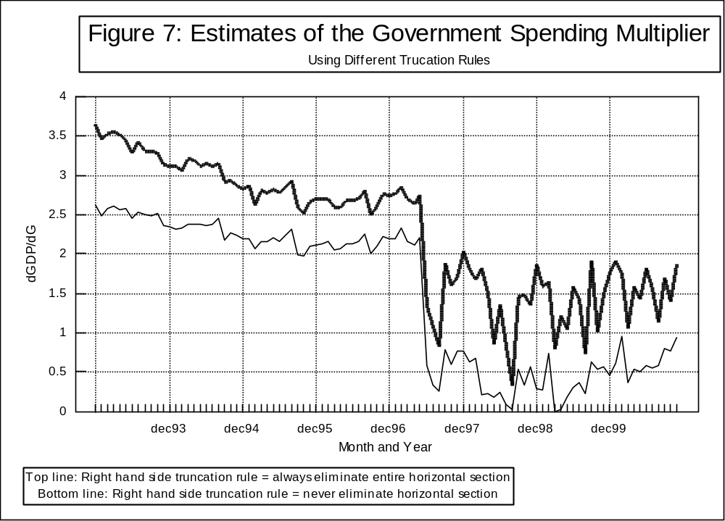
eliminating none of this horizontal region. Clearly what truncation rule is used affects the magnitude of the estimated multiplier and the amplitude of the multiplier’s fluctuations (especially after the the effects of estimating dGDP/dG when the entire right-hand horizontal section is always eliminated and the bottom line in Figure 7 shows the effects of eliminating none of this horizontal region. Clearly what truncation rule is used affects the magnitude of the estimated multiplier and the amplitude of the multiplier’s fluctuations (especially after the crisis). However, the basic shape of both curves are the same, which seems to imply that RTPLS is consistently showing if omitted variables are causing the multiplier to go up or down, regardless of what truncation rule is used.

IV. The Equation Estimated for Thailand and the Thai Data

Equations 7 through 10 were estimated where GDP is gross domestic product, CPI is the consumer price index, G is government expenditures, and M is the money supply.
- GDP = fn(G)
- GDP = fn(M)
- CPI = fn(G)
- CPI = fn(M)
Data on GDP, the money supply, government expenditures, and a manufactures index was downloaded off of the Bank of Thailand’s web page. All of the data was reported monthly except for GDP, which was reported quarterly. The principal investigator of this study contacted the National Economic and Social Development Board (NESDB), the source of the GDP data, to see if monthly data on this series could be obtained. He was told that GDP is not calculated on a monthly basis. To estimate GDP for a given month, the quarterly data that contains that month was multiplied by that month’s manufactures index and then divided by the sum of the monthly manufactures index for that quarter. Atchana Waiquamdee (2001) told this study’s principal investigator that in some Bank of Thailand studies where monthly GDP were needed, the manufacturing production index was used as a proxy. The data on nominal GDP, government purchases, and the money supply are in millions of Thai baht. The data on GDP for 1999-2000 are preliminary figures. The data used to estimate equations 7 to 10 are given in Table 1.
The data starts in January of 1993, immediately prior to the opening of the Bangkok International Banking Facilities (BIBF), and ends December 2000. The data was split into two time periods. The first time period, March 1993 to June 1997, corresponds to when Thailand had a fixed exchange rate. The second time period, July 1997 to December 2000, corresponds to when Thailand had a flexible exchange rate. The earlier time period is referred to as “before” the floating of the baht and the later time period as “after” the floating. There are 54 monthly observations before and 42 monthly observations after the floating of the baht. Between 8 and 10 iterations of TPLS were conducted for equations 7 through 10 for the before time period and between 6 and 9 iterations for the after time period. The TPLS estimate from each iteration was entered into the data for the efficient observations in that iteration. These TPLS estimates were then the dependent variable for the final regression in RTPLS. The final regression equations in the RTPLS procedure for equations 11-15 are given below and noted with an “f” for “final” regression.
7f. dGDP/dG = α₀ + α₁(1/G) + α₂(GDP/G)
8f. dGDP/dM = α₀ + α₁(1/M) + α₂(GDP/M)
9f. dCPI/dG = α₀ + α₁(1/G) + α₂(CPI/G)
10f. dCPI/dM = α₀ + α₁(1/M) + α₂(CPI/M)
After estimating 7f through 10f, data on G, M, GDP, and CPI were plugged back into the right hand side of these equations to produce the RPPLS estimates for the government spending and money supply multipliers. Finally dCPI/dM was multiplied by M/CPI and dCPI/dG was multiplied by G/CPI to change them into elasticities.
The money supply multipliers calculated are interesting in-and-of-themselves, but they are only useful if the Thai government controls its own money supply. To see to what extent the Thai government controls Thailand’s money supply, equations 11 through 13 were estimated with RTPLS.
- M-1 = fn(1/(Amount of Government Securities held by Commercial Banks))
- M-1 = fn(Bank of Thailand Loans to Commercial Banks)
- M-1 = fn(loans/reserves)
The data used in these estimations are given in the first three columns of Table 5 and column 4 of Table 1. The independent variable for equation 11, 1/securities, captures the influence of open market operations. Because TPLS requires a positive relationship between the dependant and independent variable, the inverse of securities (instead of just securities) had to be used – if the government sells additional securities to banks, then the money supply decreases. If Thailand’s central bank makes additional loans to commercial banks (perhaps after reducing the discount rate), then the money supply should increase (equation 12). The discount rate is not used since the discount rate primarily affects the money supply through the making of additional loans to commercial banks.
The Bank of Thailand requires that each commercial bank maintain certain capital adequacy ratios that are related to the assets of that commercial bank and certain provisions against the possibility of bad loans, which are related to the quantity and quality of that bank’s loans. Because variations in the amount of reserves commercial banks hold is more strongly correlated to loans than to deposits, the ratio of loans to reserves (and not the ratio of deposits to reserves) was used to capture the effects of the Thai government changing reserve requirements.
For the before the floating time period, 11, 13, and 12 TPLS iterations were conducted on equations 11, 12, and 13 respectfully. For the after time period, 14, 13, and 9 TPLS iterations were conducted on equations 11, 12, and 13 respectfully. Some of these iterations, especially for Bank of Thailand loans after the floating of the baht, consisted almost entirely of a horizontal frontier. This horizontal frontier indicates that the money supply was not related to that monetary tool for the efficient observations of that iteration.

V. The Effectiveness of Monetary Policy Tools

Two conditions must be met to make the money supply an effective tool for economic policy. First, a relatively stable relationship should exist between the money supply, GDP, and inflation. Figures 2 and 4 seem to imply that this condition is currently satisfied. The second condition is that The Bank of Thailand must be able to control the money supply.
Table 5, Columns 4-6, and Figures 8-10 imply that the Thai government could use open market operations, Bank of Thailand loans to commercial banks, and reserve requirements to change the money supply (M-1) while it maintained a fixed exchange rate. However, the effectiveness of all three of these monetary policy tools fell drastically after the floating of the Thai baht.
The numbers in the fourth column of Table 5 and Figure 8 show the relationship between the money supply and the inverse of the value of government securities held by commercial banks. For RTPLS to work, only variables that are positively related to the dependant variable could be included. Since the Thai government selling more securities to banks would reduce the money supply, the inverse of these securities had to be used. Using the inverse of securities, instead of securities themselves, makes interpreting the numbers in column 4 of Table 5 difficult. However, one thing is very clear from Figure 8, the effectiveness of open market operations declined noticeably when Thailand went from
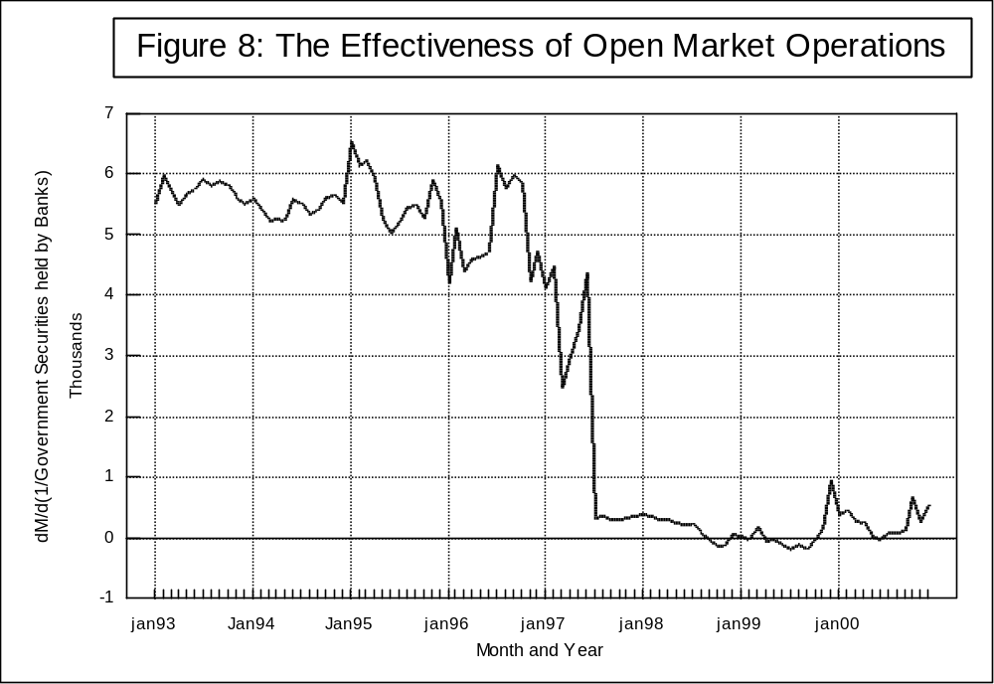
a fixed to a flexible exchange rate.
Column 5 of Table 5 and Figure 9 show the effect on the money supply of the Bank of Thailand loaning money to commercial banks. The January 1993 value for dM/d(BOT loans) of 1.424 implies that the Bank of Thailand loaning out an additional million baht to commercial banks in that month would have resulted in a 1.424 million baht increase in the Thai money supply. It is significant that when Thailand had a fixed exchange rate the change in the money supply from a one million baht increase in Bank of Thailand loans is greater than one million baht; in contrast, when Thailand had a flexible exchange rate, the change in the money supply from an increase in Bank of Thailand loans is practically zero. In other words, after the floating of the Baht, loans from the Bank of Thailand appear to have no effect on the Thai money supply.
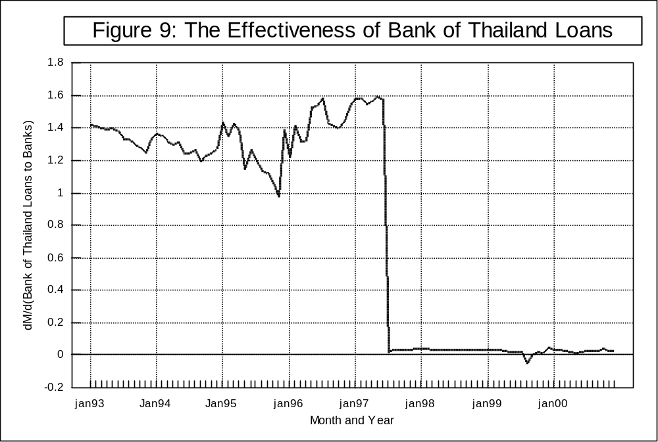

Column 6 of Table 5 and Figure 10 show that the effect of a given change in reserve requirements on the money supply also drastically fell when Thailand switched from a fixed to a flexible exchange rate. Furthermore, the relationship between reserve ratios and the money supply became noticeably less stable in 1999 and 2000. The average pre-crisis money supply multiplier for the loan to reserve ratio of 11547 implies that requiring that commercial banks loan one less baht per baht of reserves would have decreased the Thai money supply by 11.5 billion baht. In contrast, the average post-July 1997 value for this multiplier implies that the same decrease in the loan to reserve ratio would have decreased the money supply by only four billion baht. It also is interesting to note that the effectiveness of the loan to reserve ratio drastically fell the month before the crisis hit.

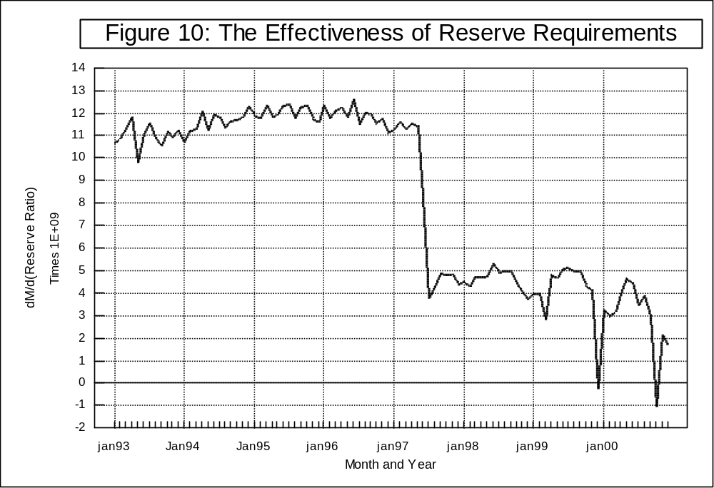

The above reported results conflict with the Mundell-Fleming model in several ways. The Mundell-Fleming model would predict that the Thai government had no control over its money supply while it was under a fixed exchange rate. This is because the buying and selling of foreign reserves, necessary to keep the exchange rate fixed, would automatically cause the money supply to change. In contrast, the Mundell-Fleming model would predict that the floating of the Thai baht would make it possible for the Thai government to control its money supply, and would enhance the effects of changes in the money supply on GDP. The effects of the money supply on GDP would be enhanced because any increase in the money supply would cause the exchange rate to fall which would result in increased exports and decreased imports, further increasing GDP.
The Mundell-Fleming prediction that governments with fixed exchange rates (that do not sterilize) have no control over their own money supply is inconsistent with this study finding pre-crisis relationships between the Thai money supply and open market operations, Bank of Thailand loans, and reserve requirements (see Figures 8-10). Remember a positive, non-zero relationship between the money supply and GDP was also found (see Figure 2). Furthermore, the finding that the money supply multiplier fell by 63 percent after Thailand floated its currency conflicts with the Mundell-Fleming hypothesis that exchange rate adjustments would augment the effects of any given change in the money supply under a flexible exchange rate regime (see Table 1 and Figure 2). In other words, the Mundell-Fleming model would lead one to expect that dGDP/dM would rise after the floating of the baht; instead of falling as it did. Indeed, experts at the Bank of Thailand, told this project’s principal investigator that they were looking forward to gaining more control over their money supply after Thailand floated its currency, but that they were disappointed (Waiquamdee, 2001).
This fall in the effectiveness of monetary policy tools and in the money supply multiplier are due to forces not incorporated into the Mundell-Fleming model. In the wake of Thailand’s financial crisis, the Bank of Thailand took a strong stand against Thailand’s financial institutions, shutting down 64 percent of Thailand’s finance and securities companies and forcing write-downs of the equity and changes in the management of many of Thailand’s remaining financial firms. The remaining financial firms were very scared of possible government takeover, management changes, and stock devaluations if they did not get their non-performing loans under control. To make the situation worse, many debtors engaged in the strategic non-payment of loans (not paying on their loans, even when they were capable of paying), in order to try to get their loans restructured in a more favorable fashion or out of fear of not being able to acquire future loans. In response, banks greatly reduced their lending (Leightner, forthcoming). As a consequence there continues to be excess liquidity in the Thai financial market while many firms cannot acquire loans. If banks refuse to loan, then the Bank of Thailand cannot control the money supply and any action that the government takes to increase the money supply would have a greatly reduced effect on the money supply and on GDP.
According to Teerana Bhongmakapat (2001), another force not incorporated into the Mundell-Fleming model is the increased exchange rate risk under a flexible exchange rate. If this increased exchange rate risk causes a decline in the demand for a currency then the government’s control of the money supply would be diminished, resulting in a relatively weak link between the money supply and exchange rate changes. Since Thailand’s currency fell from 25 baht per dollar in June of 1997 to 54 baht per dollar in January 1998, but partially rebounded to 43 baht per dollar in December of 2000, this increased exchange rate risk is not minor for Thailand. No matter what the reason, it is clear from the evidence presented in this report that Thailand’s monetary policy is not more effective under a flexible exchange rate than it was under a fixed exchange rate. Perhaps sometime in the future it will be, but not yet.

VI. A Brief Discussion of Monetary Policy in Thailand

The Bank of Thailand’s image as one of the best central banks in the world was tarnished in 1996 (see Yuthamanop (1997) for details). In the first half of 1997, the Bank of Thailand spent more than 30 billion dollars (out of approximately 39 billion dollars of reserves) in a failed attempt to defend Thailand’s fixed exchange rate between the Baht and the US dollar (Bank of Thailand, 1997). Because the Bank of Thailand used swaps in some of its efforts to defend the baht, the total amount of money the Bank of Thailand had spent on defending the baht was not revealed until after the July 2, 1997 floating of the baht. Civil charges were filed in December of 2001 against former governor of the Bank of Thailand, Rerngchai Marakanond accusing him of causing approximately 186 billion baht of damage to Thailand via his defense of the Thai baht (Yuthamanop, 2002a). Furthermore, in 1997 and 1998, the Bank of Thailand came under heavy criticism for shutting down certain finance and securities companies and not others.
“M.R. Chatumongol Sonakul, appointed central bank governor under the Chuan government and widely credited with helping the institution regain market credibility, was sacked in late May [2001] after weeks of debate over interest-rate policy” (Yuthamanop, 2001). Central banks being independent of political influence is important if foreign confidence in an economy is to be increased or maintained.
For most of 1985 through 1996, the Bank of Thailand maintained interest rates that were higher than world interest rates. The resulting in-flow of foreign capital kept the quantity demanded for baht higher than the quantity supplied of baht at the official fixed exchange rate. The resulting shortage of baht was covered by the Thai government selling baht for dollars, which resulted in Thai reserves of US dollars increasing from 2.7 billion, in late 1984, to 39 billion, in January of 1997.
The post-crisis central bank of Thailand, under Sonakul’s leadership, set up a monetary policy board (MPB), which used the 14-day repurchase rate to keep core inflation within the range of zero to 3.5 percent (Bank of Thailand, 2001). Avoiding a negative rate of inflation (or “deflation”) is important, as illustrated by Japan’s recent severe problems with deflation (“Policy Mix,” 1998). Avoiding significant inflation is important, especially since the Thai Rak Thai (translated as Thai Love Thai) political party was elected into power in January 2001 in the biggest land-slide victory in Thai history on a platform that promised massive increases in government spending. Apparently, in early 2001, the Bank of Thailand believed that the lower end of the targeted inflation range was a greater immediate threat as evidenced by the central bank promoting domestic interest rates that were lower than world interest rates. Furthermore, both the central bank and the International Monetary Fund saw a low interest rate as important to Thailand re-establishing economic growth and necessary for debt restructuring. Thai interest rates being lower than world interest rates lead to capital out-flows which caused a decline in the value of the Thai baht. The central bank argued that neither of these results were a problem since the exchange rate had not fallen much (from a February 1, 2001 high of 42.26 baht per US$ to a April 26, 2001 low of 45.73 baht per US$) and the capital outflows were due to Thai debtors taking out cheaper domestic loans to pay off their more expensive foreign loans. Indeed, Thailand’s foreign debt burden fell from a high of US$ 102 billion in mid-1997 to US$ 76 billion by the end of March 2001 (Yuthamanop, 2001).
The Thai Rak Thai party, lead by Prime Minister Thaksin Shinawatra and Finance Minister Somkid Jatusripitak, disagreed with the central bank’s low interest rate policy. The Thai Rak Thais argued that the goal of monetary policy should be economic stability, not growth. This was viewed as a repudiation of Sonakul’s inflation targeting for price stability and sustainable growth. On May 29, 2001, the Thai Rak Thai government voted unanimously to remove Chatumongol from the position of Governor of the Bank of Thailand. The Thai Rak Thais stressed that this firing was not due to interest-rate policy instead it was due to a lack of coordination and co-operation. The new central bank governor, M.R. Pridiyathorn Davakula increased the Thai 14-day repurchase rate by one percentage point to 2.5% (Yuthamanop, 2001). This rising of interest rates is the direct opposite of global trends. For example, the US Federal Reserve progressively cut interest rates in 2001 from 6.5% in January to 1.75%, which is its lowest level in 40 years.
In the second quarter of 2001, before the increase in Thai domestic interest rates, Thai foreign debt repayments averaged US$ 800 million to $ 1 billion per month; after the increase in interest rates, foreign debt repayments fell to US$ 500 million per month (Yuthamanop, 2002b). Meanwhile, the baht climbed from a year-low of 45.80 baht per US$ on July 20, 2001 to a high of 43.68 baht to the US$ on December 13, 2001.
What additional light do the empirical results from this study shed on the brief monetary policy history given above? First, the results of Section V imply that the Bank of Thailand could not effectively control the Thai money supply from July 1997 to December 2000. Thus monetary policies that focus on interest rates, instead of on the money supply, were preferable during this time period. Second, the major reason why the Bank of Thailand could not control its money supply is that commercial banks refused to loan money, contributing to an estimated 500 billion baht of excess liquidity, as of the end of 2001 (Yuthamanop, 2002b). Banks refuse to make additional loans because they are scared of the future. Banks are scared because they do not know if the economy will continue to recover, because they do not know if loans will be paid back since many debtors have turned to strategically not paying their loans, and because recent history includes the central bank shutting down 64% of finance and securities companies and taking over 26% of commercial banks (Leightner 1999b and forthcoming). If the Thai government wants to increase its control over the money supply and the economy, then it must (some how) reduce this fear. The longer the economy remains stable and/or grows, the more the fear will subside.
Both those who support lower interest rates and those who support higher interest rates would argue that their policies produce the greatest stability and growth. Although this study does not provide evidence for whether a high or a low interest rate causes more stability and growth, this study does emphasize the importance of judging any policy on the basis of how it affects internal and external expectations and fears. This study’s results show that immeasurable variables like fear and uncertainty greatly reduce the effectiveness of both fiscal and monetary policy.

VII. Conclusion

The Thai case involves many omitted (and often immeasurable) variables, like (1) a self-reinforcing increase in property values leading to a speculative bubble in 1995-1996, (2) rising then plummeting international expectations, (3) re-contagion effects as Thailand’s financial crisis spread throughout Asia and even to Brazil and Russia, which further diminished international expectations for Thailand, (4) escalating fear in the banking sector of increased competition prior to the crisis which turned into fear of government take over after the crisis, and (5) a drying up of credit in the wake of the crisis and the strategic non-payment of loans. These omitted variables probably affect government spending and money supply multipliers for Thailand.
This project introduces a new analytical technique called Reiterative Truncated Projected Least Squares (RTPLS). Simulation tests indicate that RTPLS works much better than OLS when there are omitted, unknown, or un-measurable variables that interact with the included variables. RTPLS produces a government spending multiplier of approximately 3 for Thailand prior to the floating of the Thai currency, but this multiplier falls to 0.76 after the float. The pre-crisis money supply multiplier for Thailand is approximately 0.75 but this multiplier also plummets to 0.28 after the float. Contrary to the Mundell-Fleming model, the effectiveness of open market operations, Bank of Thailand loans, and reserve requirements, fell after Thailand floated its currency.
After changing its fixed exchange rate to a flexible one, the Thai government has a difficult job. The economic models that they had developed under a fixed exchange rate no longer apply. Since the floating of the baht, many immeasurable variables probably interact with Thai government policy in ways that cannot easily be modeled, especially with the limited data that has been accumulated since the floating of the baht. The government spending and money supply multipliers for Thailand using RTPLS have fallen drastically after the floating as have the effectiveness of its tools for controlling the money supply. Furthermore, the government spending multiplier and the effectiveness of reserve requirements are noticeably less stable after the float than before the float, which makes the effective use of government policy even more difficult. Probably the most important immeasurable variables affecting the functioning of Thai economic policy are expectations. The Thai government should try diligently to re-establish both domestic and international confidence in Thailand. Hopefully this study and RTPLS will help Thai government officials in their efforts to improve the Thai economy and the welfare of all Thais.
It would probably be beneficial to (1) conduct similar studies of other crisis-hit countries, (2) continuously update the after-crisis analysis as additional data becomes available, and (3) test to see how much control the Bank of Thailand has over market interest rates in Thailand. Furthermore, a RTPLS study comparing and contrasting what happened after the crisis in Malaysia and in Thailand would be very interesting since Malaysia chose to impose strong capital controls and maintain its fixed exchange rate while Thailand imposed weaker capital controls and floated its currency.

Table 1: The Data, Spending Multipliers, and Money Multipliers

 | GDP | CPI | G | Money  (M-1) | dGDP  dG | dGDP  dM | %dCPI  %dG | %dCPI  %dM
jan93 | 255559 | 0.950 | 48265 | 243736 | 3.65 | 0.692 | 0.213 | 0.271
feb93 | 262022 | 0.936 | 33582 | 249312 | 3.45 | 0.777 | 0.150 | 0.290
Mar93 | 244591 | 0.929 | 33603 | 249811 | 3.53 | 0.730 | 0.149 | 0.292
apr93 | 252338 | 0.936 | 37333 | 249540 | 3.55 | 0.688 | 0.161 | 0.290
May93 | 275659 | 0.956 | 42146 | 247820 | 3.52 | 0.698 | 0.179 | 0.281
June93 | 253131 | 0.946 | 38399 | 259153 | 3.45 | 0.768 | 0.161 | 0.322
July93 | 274358 | 0.967 | 54212 | 251940 | 3.29 | 0.848 | 0.225 | 0.307
Aug93 | 248578 | 0.944 | 40530 | 256205 | 3.43 | 0.736 | 0.172 | 0.309
Sept93 | 260380 | 0.958 | 41862 | 257859 | 3.30 | 0.825 | 0.170 | 0.324
oct93 | 273859 | 0.966 | 47469 | 258833 | 3.30 | 0.795 | 0.193 | 0.312
Nov93 | 275806 | 0.963 | 57681 | 269611 | 3.29 | 0.763 | 0.232 | 0.309
Dec93 | 284020 | 0.985 | 38823 | 303711 | 3.14 | 0.748 | 0.156 | 0.313
Jan94 | 314667 | 1.022 | 38892 | 305306 | 3.12 | 0.749 | 0.151 | 0.308
feb94 | 297858 | 1.002 | 50458 | 290716 | 3.11 | 0.731 | 0.200 | 0.297
Mar94 | 293007 | 1.003 | 44366 | 293659 | 3.06 | 0.753 | 0.173 | 0.300
apr94 | 295254 | 0.974 | 43249 | 297552 | 3.21 | 0.685 | 0.177 | 0.319
May94 | 295254 | 0.978 | 40879 | 303085 | 3.20 | 0.654 | 0.165 | 0.320
June94 | 293977 | 0.968 | 45984 | 296156 | 3.12 | 0.782 | 0.183 | 0.354
July94 | 285667 | 0.996 | 40912 | 317109 | 3.14 | 0.753 | 0.160 | 0.365
Aug94 | 304109 | 0.983 | 47585 | 307351 | 3.12 | 0.709 | 0.186 | 0.339
Sept94 | 298076 | 1.008 | 50272 | 314102 | 3.15 | 0.721 | 0.186 | 0.346
oct94 | 302131 | 1.018 | 74373 | 315095 | 2.91 | 0.800 | 0.286 | 0.360
Nov94 | 325554 | 1.016 | 53063 | 315640 | 2.93 | 0.808 | 0.200 | 0.343
Dec94 | 355574 | 1.089 | 42900 | 363125 | 2.87 | 0.763 | 0.150 | 0.330
Jan95 | 326373 | 1.025 | 45945 | 353039 | 2.83 | 0.736 | 0.172 | 0.341
feb95 | 333909 | 1.038 | 46317 | 353339 | 2.87 | 0.702 | 0.172 | 0.341
Mar95 | 338899 | 1.014 | 57811 | 346434 | 2.63 | 0.859 | 0.216 | 0.348
apr95 | 371796 | 1.029 | 55325 | 352052 | 2.81 | 0.727 | 0.206 | 0.356
May95 | 336467 | 1.021 | 50438 | 353335 | 2.78 | 0.723 | 0.187 | 0.354
June95 | 345871 | 1.060 | 51911 | 354106 | 2.83 | 0.742 | 0.183 | 0.354
July95 | 376426 | 1.089 | 49620 | 358277 | 2.78 | 0.765 | 0.171 | 0.363
Aug95 | 346914 | 1.056 | 58478 | 364028 | 2.86 | 0.730 | 0.206 | 0.373
Sept95 | 345157 | 1.049 | 51888 | 369188 | 2.94 | 0.719 | 0.182 | 0.392
oct95 | 342714 | 1.080 | 73110 | 367544 | 2.59 | 0.773 | 0.254 | 0.393
Nov95 | 346573 | 1.069 | 62339 | 368378 | 2.52 | 0.855 | 0.217 | 0.404
Dec95 | 364921 | 1.089 | 54453 | 388276 | 2.67 | 0.737 | 0.185 | 0.383
jan96 | 359662 | 1.096 | 54655 | 385071 | 2.71 | 0.729 | 0.184 | 0.388
feb96 | 383724 | 1.110 | 58854 | 411126 | 2.70 | 0.661 | 0.195 | 0.370
Mar96 | 368280 | 1.101 | 60056 | 426516 | 2.70 | 0.738 | 0.199 | 0.396
apr96 | 376287 | 1.115 | 63742 | 393146 | 2.59 | 0.739 | 0.210 | 0.375
May96 | 375417 | 1.117 | 62313 | 408219 | 2.60 | 0.745 | 0.204 | 0.384
June96 | 404704 | 1.136 | 62719 | 395438 | 2.69 | 0.760 | 0.202 | 0.393
July96 | 391904 | 1.114 | 63911 | 418870 | 2.68 | 0.721 | 0.209 | 0.409
Aug96 | 383007 | 1.164 | 76978 | 396390 | 2.70 | 0.785 | 0.240 | 0.389
Sept96 | 370615 | 1.149 | 68540 | 428005 | 2.81 | 0.763 | 0.215 | 0.418
oct96 | 401420 | 1.141 | 69974 | 406798 | 2.51 | 0.840 | 0.222 | 0.420
Nov96 | 389590 | 1.128 | 73539 | 399331 | 2.60 | 0.801 | 0.236 | 0.409
Dec96 | 398084 | 1.162 | 71651 | 430283 | 2.76 | 0.729 | 0.222 | 0.409
jan97 | 376566 | 1.144 | 72097 | 418056 | 2.75 | 0.703 | 0.227 | 0.412
feb97 | 387674 | 1.157 | 73373 | 418231 | 2.76 | 0.665 | 0.229 | 0.402
Mar97 | 392147 | 1.105 | 75038 | 421926 | 2.86 | 0.782 | 0.243 | 0.431
apr97 | 390107 | 1.141 | 83163 | 423686 | 2.71 | 0.734 | 0.262 | 0.431
May97 | 389590 | 1.130 | 91119 | 408321 | 2.64 | 0.736 | 0.289 | 0.411
June97 | 411942 | 1.155 | 123723 | 426971 | 2.76 | 0.772 | 0.384 | 0.461
july97 | 368571 | 1.274 | 52653 | 409563 | 0.96 | 0.312 | -0.020 | 0.222
aug97 | 372898 | 1.281 | 60297 | 389058 | 0.38 | 0.279 | -0.010 | 0.170
Sept97 | 373118 | 1.286 | 53278 | 437024 | 0.17 | 0.289 | -0.005 | 0.184
oct97 | 376832 | 1.288 | 81349 | 381672 | 1.55 | 0.310 | -0.009 | 0.148
nov97 | 376809 | 1.275 | 59825 | 415746 | 1.09 | 0.300 | -0.001 | 0.150
dec97 | 368467 | 1.292 | 104444 | 389288 | 1.47 | 0.303 | -0.002 | 0.140
jan98 | 375261 | 1.289 | 64901 | 398902 | 1.54 | 0.289 | 0.005 | 0.129
feb98 | 374580 | 1.287 | 59110 | 426895 | 1.19 | 0.288 | 0.009 | 0.125
Mar98 | 368867 | 1.294 | 78518 | 389875 | 1.25 | 0.305 | 0.020 | 0.094
apr98 | 396338 | 1.298 | 59439 | 513057 | 0.34 | 0.269 | 0.022 | 0.110
May98 | 386543 | 1.293 | 59513 | 507349 | 0.30 | 0.281 | 0.024 | 0.092
June98 | 397207 | 1.284 | 59726 | 455697 | 0.01 | 0.288 | 0.024 | 0.070
july98 | 405981 | 1.242 | 59998 | 443804 | 0.27 | 0.279 | 0.028 | 0.075
aug98 | 380847 | 1.286 | 63715 | 406126 | -0.17 | 0.277 | 0.028 | 0.057
Sept98 | 399524 | 1.290 | 70683 | 399259 | -0.45 | 0.277 | 0.026 | 0.058
oct98 | 407483 | 1.172 | 77308 | 393509 | 0.92 | 0.302 | 0.038 | 0.069
nov98 | 395614 | 1.300 | 61224 | 477900 | 0.50 | 0.282 | 0.027 | 0.083
dec98 | 399195 | 1.251 | 62571 | 430589 | 0.93 | 0.289 | 0.023 | 0.093
jan99 | 386360 | 1.208 | 87045 | 400523 | 0.51 | 0.263 | 0.045 | 0.083
feb99 | 360342 | 1.274 | 62717 | 441141 | 0.39 | 0.268 | 0.029 | 0.083
Mar99 | 406779 | 1.265 | 67744 | 405877 | 1.37 | 0.290 | 0.028 | 0.086
apr99 | 412102 | 1.218 | 64864 | 407307 | -0.37 | 0.257 | 0.024 | 0.090
May99 | 402358 | 1.228 | 68230 | 407863 | -0.21 | 0.251 | 0.024 | 0.099
June99 | 383807 | 1.280 | 65874 | 433226 | 0.07 | 0.267 | 0.021 | 0.099
july99 | 361039 | 1.279 | 76165 | 424980 | 0.46 | 0.274 | 0.027 | 0.092
aug99 | 387896 | 1.203 | 77902 | 428374 | 0.54 | 0.274 | 0.032 | 0.096
Sept99 | 416162 | 1.228 | 69994 | 428785 | 0.07 | 0.274 | 0.025 | 0.091
oct99 | 374295 | 1.273 | 73305 | 429226 | 1.23 | 0.277 | 0.032 | 0.091
nov99 | 383807 | 1.282 | 89783 | 431901 | 0.79 | 0.283 | 0.033 | 0.092
dec99 | 396709 | 1.296 | 66575 | 470765 | 0.98 | 0.246 | 0.029 | 0.112
jan00 | 405209 | 1.281 | 75988 | 441733 | 0.83 | 0.253 | 0.039 | 0.092
feb00 | 399336 | 1.308 | 68442 | 477842 | 1.21 | 0.258 | 0.038 | 0.093
Mar00 | 414414 | 1.285 | 71114 | 458041 | 1.86 | 0.293 | 0.035 | 0.086
apr00 | 397803 | 1.298 | 71017 | 463098 | 0.45 | 0.261 | 0.031 | 0.091
May00 | 428653 | 1.307 | 70221 | 525691 | 0.96 | 0.271 | 0.035 | 0.095
June00 | 401447 | 1.290 | 70702 | 575039 | 0.85 | 0.275 | 0.035 | 0.100
july00 | 414523 | 1.286 | 91465 | 476373 | 1.11 | 0.268 | 0.052 | 0.084
aug00 | 420132 | 1.306 | 71775 | 536188 | 0.98 | 0.271 | 0.042 | 0.082
Sept00 | 414967 | 1.312 | 86907 | 483467 | 0.91 | 0.281 | 0.045 | 0.070
oct00 | 391969 | 1.294 | 80296 | 491642 | 1.53 | 0.269 | 0.044 | 0.092
nov00 | 435517 | 1.299 | 75285 | 494989 | 1.36 | 0.286 | 0.039 | 0.081
dec00 | 427171 | 1.308 | 82499 | 495548 | 1.86 | 0.278 | 0.046 | 0.089
mean:
before | 332374 | 1.046 | 56480 | 343719 | 2.95 | 0.749 | 0.202 | 0.358
After | 393975 | 1.276 | 70821 | 445117 | 0.76 | 0.279 | 0.025 | 0.101

Table 2: The Data for Figures 5 and 6
(Means Given in Last Row)

X₁ | X₂ | X₃ | Y₁ | Φ | Φ*Y₁
6 | 152 | 323 | 360 | 1 | 360
11 | 734 | 946 | 1529 | 1 | 1529
16 | 227 | 227 | 520 | 3.4917 | 1816
17 | 903 | 802 | 1873 | 1 | 1873
21 | 511 | 509 | 1093 | 1.7200 | 1880
34 | 630 | 424 | 1344 | 1.4156 | 1903
50 | 311 | 43 | 722 | 2.6735 | 1930
51 | 387 | 209 | 875 | 2.2080 | 1932
51 | 730 | 626 | 1561 | 1.2377 | 1932
58 | 316 | 519 | 740 | 2.6273 | 1944
79 | 731 | 431 | 1591 | 1.2449 | 1981
100 | 610 | 857 | 1370 | 1.4723 | 2017
104 | 27 | 543 | 208 | 9.7310 | 2024
106 | 856 | 689 | 1868 | 1.0854 | 2028
120 | 700 | 42 | 1570 | 1.3069 | 2052
125 | 796 | 530 | 1767 | 1.1661 | 2061
131 | 63 | 142 | 307 | 6.7457 | 2071
131 | 61 | 452 | 303 | 6.8347 | 2071
137 | 518 | 198 | 1223 | 1.7018 | 2081
165 | 865 | 315 | 1945 | 1.0951 | 2130
175 | 921 | 43 | 2067 | 1.0389 | 2147
179 | 832 | 370 | 1893 | 1.1380 | 2154
180 | 963 | 296 | 2156 | 1 | 2156
187 | 689 | 276 | 1615 | 1.3406 | 2165
191 | 406 | 844 | 1053 | 2.0610 | 2170
198 | 872 | 603 | 1992 | 1.0940 | 2179
218 | 542 | 396 | 1352 | 1.6311 | 2205
232 | 340 | 855 | 962 | 2.3112 | 2223
236 | 99 | 282 | 484 | 4.6045 | 2229
262 | 907 | 157 | 2126 | 1.0641 | 2262
271 | 447 | 361 | 1215 | 1.8716 | 2274
279 | 591 | 231 | 1511 | 1.5118 | 2284
290 | 24 | 906 | 388 | 5.9242 | 2299
303 | 153 | 487 | 659 | 3.5136 | 2315
306 | 651 | 993 | 1658 | 1.3989 | 2319
307 | 908 | 804 | 2173 | 1.0679 | 2321
316 | 910 | 650 | 2186 | 1.0669 | 2332
357 | 570 | 307 | 1547 | 1.5420 | 2385
397 | 217 | 814 | 881 | 2.7665 | 2437
407 | 754 | 217 | 1965 | 1.2470 | 2450
420 | 526 | 483 | 1522 | 1.6210 | 2467
423 | 999 | 782 | 2471 | 1 | 2471
428 | 750 | 585 | 1978 | 1.2511 | 2475
439 | 950 | 350 | 2389 | 1.0393 | 2483
445 | 615 | 141 | 1725 | 1.4420 | 2487
446 | 173 | 262 | 842 | 2.9550 | 2488
458 | 866 | 901 | 2240 | 1.1148 | 2497
475 | 730 | 575 | 1985 | 1.2644 | 2510
493 | 4 | 405 | 551 | 4.5793 | 2523
500 | 496 | 839 | 1542 | 1.6397 | 2528
502 | 937 | 698 | 2426 | 1.0428 | 2530
504 | 926 | 934 | 2406 | 1.0521 | 2531
512 | 166 | 315 | 894 | 2.8382 | 2537
532 | 839 | 435 | 2260 | 1.1293 | 2552
541 | 793 | 469 | 2177 | 1.1755 | 2559
546 | 634 | 398 | 1864 | 1.3748 | 2563
553 | 101 | 281 | 805 | 3.1900 | 2568
596 | 604 | 267 | 1854 | 1.4024 | 2600
597 | 140 | 216 | 927 | 2.8055 | 2601
622 | 274 | 998 | 1220 | 2.1470 | 2619
627 | 562 | 491 | 1801 | 1.4565 | 2623
652 | 496 | 16 | 1694 | 1.5595 | 2642
669 | 347 | 971 | 1413 | 1.8786 | 2654
670 | 0 | 538 | 720 | 3.6877 | 2655
693 | 905 | 808 | 2553 | 1.0467 | 2672
703 | 75 | 690 | 903 | 2.9676 | 2680
708 | 407 | 193 | 1572 | 1.7070 | 2683
716 | 899 | 435 | 2564 | 1.0489 | 2689
716 | 471 | 422 | 1708 | 1.5746 | 2689
718 | 6 | 934 | 780 | 3.4499 | 2691
742 | 582 | 945 | 1956 | 1.3849 | 2709
748 | 619 | 80 | 2036 | 1.3327 | 2713
751 | 74 | 53 | 949 | 2.8615 | 2716
751 | 473 | 287 | 1747 | 1.5544 | 2716
753 | 832 | 275 | 2467 | 1.1013 | 2717
762 | 464 | 270 | 1740 | 1.5654 | 2724
778 | 545 | 925 | 1918 | 1.4263 | 2736
782 | 198 | 51 | 1228 | 2.2302 | 2739
788 | 56 | 831 | 950 | 2.8875 | 2743
799 | 787 | 37 | 2423 | 1.1355 | 2751
815 | 382 | 883 | 1629 | 1.6963 | 2763
816 | 269 | 910 | 1404 | 1.9687 | 2764
825 | 778 | 235 | 2431 | 1.1397 | 2771
841 | 653 | 305 | 2197 | 1.2666 | 2783
854 | 765 | 763 | 2434 | 1.1472 | 2792
855 | 415 | 314 | 1735 | 1.6098 | 2793
857 | 201 | 340 | 1309 | 2.1349 | 2795
884 | 155 | 944 | 1244 | 2.2626 | 2815
889 | 529 | 848 | 1997 | 1.4113 | 2818
892 | 349 | 885 | 1640 | 1.7199 | 2821
900 | 774 | 47 | 2498 | 1.1316 | 2827
905 | 662 | 367 | 2279 | 1.2419 | 2830
909 | 193 | 23 | 1345 | 2.1066 | 2833
914 | 803 | 931 | 2570 | 1.1039 | 2837
926 | 935 | 533 | 2846 | 1 | 2846
963 | 651 | 366 | 2315 | 1.2294 | 2846
965 | 687 | 678 | 2389 | 1.1913 | 2846
976 | 473 | 107 | 1972 | 1.4432 | 2846
989 | 780 | 691 | 2599 | 1.0950 | 2846
997 | 415 | 758 | 1877 | 1.5162 | 2846
493.34 | 531.14 | 492.33 | 1605.02 | 1.9329 | 2437.73

Table 3: RTPLS and OLS Results

 | % Mean error |  |  | % Maximum error
 | OLS | RTPLS | OLS/RTPLS | OLS | RTPLS | OLS/RTPLS
I. Y = 50 + 100X1 + X1*X2
Run 1 | 94 | 13 | 7.52 | 511 | 42 | 12.30
Run 2 | 64 | 23 | 2.82 | 513 | 95 | 5.41
Run 3 | 90 | 17 | 5.32 | 459 | 29 | 15.82
Run 4 | 70 | 10 | 7.22 | 434 | 19 | 22.37
Run 5 | 68 | 21 | 3.17 | 446 | 38 | 11.72
Run 6 | 67 | 6 | 10.82 | 445 | 10 | 46.32
Run 7 | 61 | 9 | 6.97 | 429 | 41 | 10.59
Run 8 | 64 | 7 | 9.38 | 342 | 8 | 44.21
Run 9 | 70 | 7 | 9.64 | 470 | 12 | 38.54
Run 10 | 75 | 9 | 8.56 | 433 | 36 | 12.04
Mean | 72 | 12 | 7.14 | 448 | 33 | 21.93

II. Y = 50 + 100X1 + 0.1*X1*X2
Run 11 | 20.6 | 4.8 | 4.25 | 52.5 | 14.5 | 3.61
Run 12 | 16.4 | 13.1 | 1.25 | 54.1 | 25.9 | 2.09
Run 13 | 19.5 | 11.1 | 1.76 | 46.4 | 17.0 | 2.73
Run 14 | 17.7 | 12.3 | 1.44 | 44.9 | 26.6 | 1.69
Run 15 | 18.1 | 10.3 | 1.76 | 44.6 | 15.6 | 2.85
Run 16 | 17.7 | 5.6 | 3.13 | 51.9 | 6.3 | 8.19
Run 17 | 16.5 | 10.5 | 1.58 | 46.4 | 16.5 | 2.81
Run 18 | 17.8 | 6.3 | 2.83 | 42.9 | 8.7 | 4.93
Run 19 | 17.3 | 8.0 | 2.17 | 47.4 | 18.1 | 2.62
Run 20 | 17.0 | 4.8 | 3.54 | 47.1 | 7.2 | 6.53
Mean | 17.9 | 8.7 | 2.37 | 47.8 | 15.6 | 3.81

III. Y = 50 + 100X1 + 0.01*X1*X2
Run 21 | 2.61 | 0.57 | 4.62 | 5.26 | 1.41 | 3.73
Run 22 | 2.25 | 1.48 | 1.52 | 5.44 | 3.49 | 1.56
Run 23 | 2.67 | 1.41 | 1.90 | 5.11 | 4.33 | 1.18
Run 24 | 2.41 | 1.44 | 1.67 | 4.95 | 4.40 | 1.12
Run 25 | 2.55 | 1.61 | 1.58 | 4.98 | 4.38 | 1.14
Run 26 | 2.36 | 0.79 | 3.00 | 5.28 | 1.64 | 3.22
Run 27 | 2.29 | 1.44 | 1.59 | 4.68 | 4.13 | 1.13
Run 28 | 2.47 | 0.91 | 2.71 | 4.77 | 2.55 | 1.87
Run 29 | 2.39 | 1.57 | 1.53 | 4.76 | 4.50 | 1.06
Run 30 | 2.20 | 1.09 | 2.01 | 4.76 | 2.73 | 1.74
Mean | 2.42 | 1.23 | 2.21 | 5.00 | 3.36 | 1.78

* The mean and maximum error was calculated by taking the absolute value of the true coefficient minus the estimated coefficient and then dividing that absolute value by the true coefficient for each observation. The result of this division was then multiplied by 100 to change it into a percent. The mean value for all these percents was then taken for columns 1 and 2; while the maximum of these percents was taken for columns 4 and 5.

Table 4:
RTPLS and OLS Results when RTPLS is used to Project Coefficients for all Observations except for the 3% that correspond to the smallest included Variables.

 | % Mean error |  |  | % Maximum error
 | OLS | RTPLS | OLS/RTPLS | OLS | RTPLS | OLS/RTPLS
I. Y = 50 + 100X1 + X1*X2
Run 1 | 94 | 30 | 3.15 | 511 | 142 | 3.59
Run 2 | 64 | 56 | 1.14 | 513 | 392 | 1.31
Run 3 | 90 | 21 | 4.23 | 459 | 52 | 8.80
Run 4 | 70 | 16 | 4.31 | 434 | 182 | 2.38
Run 5 | 68 | 38 | 1.81 | 446 | 256 | 1.74
Run 6 | 67 | 7 | 9.73 | 445 | 28 | 16.04
Run 7 | 61 | 9 | 6.82 | 429 | 39 | 11.09
Run 8 | 64 | 5 | 11.94 | 342 | 8 | 44.21
Run 9 | 70 | 14 | 4.93 | 470 | 82 | 5.70
Run 10 | 75 | 38 | 2.00 | 433 | 228 | 1.90
Mean | 72 | 23 | 5.01 | 448 | 141 | 9.68

II. Y = 50 + 100X1 + 0.1*X1*X2
Run 11 | 20.6 | 5.7 | 3.58 | 52.5 | 14.7 | 3.57
Run 12 | 16.4 | 16.1 | 1.02 | 54.1 | 40.1 | 1.35
Run 13 | 19.5 | 12.3 | 1.58 | 46.4 | 33.5 | 1.39
Run 14 | 17.7 | 17.4 | 1.02 | 44.9 | 79.1 | 0.57
Run 15 | 18.1 | 12.9 | 1.41 | 44.6 | 49.0 | 0.91
Run 16 | 17.7 | 5.26 | 3.36 | 51.9 | 6.3 | 8.19
Run 17 | 16.5 | 12.4 | 1.34 | 46.4 | 24.8 | 1.87
Run 18 | 17.8 | 7.5 | 2.36 | 42.9 | 25.9 | 1.66
Run 19 | 17.3 | 8.6 | 2.01 | 47.4 | 28.6 | 1.66
Run 20 | 17.0 | 4.8 | 3.56 | 47.1 | 9.4 | 5.01
Mean | 17.9 | 10.3 | 2.12 | 47.8 | 31.1 | 2.62

III. Y = 50 + 100X1 + 0.01*X1*X2
Run 21 | 2.61 | 0.59 | 4.40 | 5.26 | 1.41 | 3.73
Run 22 | 2.25 | 1.35 | 1.67 | 5.44 | 3.49 | 1.56
Run 23 | 2.67 | 1.43 | 1.87 | 5.11 | 6.36 | 0.80
Run 24 | 2.41 | 1.61 | 1.50 | 4.95 | 7.84 | 0.63
Run 25 | 2.55 | 1.45 | 1.75 | 4.98 | 4.38 | 1.14
Run 26 | 2.36 | 0.70 | 3.38 | 5.28 | 1.64 | 3.22
Run 27 | 2.29 | 1.31 | 1.75 | 4.68 | 4.13 | 1.13
Run 28 | 2.47 | 0.90 | 2.76 | 4.77 | 3.41 | 1.40
Run 29 | 2.39 | 1.47 | 1.63 | 4.76 | 4.50 | 1.06
Run 30 | 2.20 | 1.22 | 1.80 | 4.76 | 2.78 | 1.71
Mean | 2.42 | 1.20 | 2.25 | 5.00 | 3.99 | 1.64

Table 5: The Effectiveness of Monetary Policy Tools

 | Government  securities | BOT loans  to banks | loans  reserves | dM  d(1/securities) | dM  d(BOT loans) | dM  d(loans/reserves)
jan93 | 71.5 | 35.9 | 34.18 | 5512.5 | 1.424 | 10682
feb93 | 54.0 | 34.7 | 35.14 | 5976.8 | 1.415 | 10872
mar93 | 65.4 | 32.7 | 37.51 | 5676.6 | 1.401 | 11296
apr93 | 67.4 | 31.5 | 40.84 | 5498.8 | 1.398 | 11810
may93 | 59.2 | 31.6 | 30.40 | 5678.6 | 1.402 | 9819
june93 | 66.2 | 31.2 | 36.10 | 5763.4 | 1.383 | 11052
july93 | 57.1 | 26.3 | 38.94 | 5920.1 | 1.337 | 11529
aug93 | 54.7 | 25.1 | 34.97 | 5827.7 | 1.335 | 10837
sept93 | 55.9 | 23.7 | 33.42 | 5886.3 | 1.308 | 10524
oct93 | 55.0 | 21.4 | 36.96 | 5804.2 | 1.281 | 11200
nov93 | 55.7 | 18.8 | 35.35 | 5616.0 | 1.248 | 10907
dec93 | 47.8 | 21.2 | 37.32 | 5510.8 | 1.333 | 11254
Jan94 | 45.2 | 23.8 | 34.38 | 5594.7 | 1.370 | 10710
feb94 | 48.0 | 22.0 | 37.05 | 5409.8 | 1.355 | 11206
mar94 | 50.7 | 19.5 | 37.43 | 5238.5 | 1.324 | 11270
apr94 | 51.4 | 18.7 | 43.04 | 5261.4 | 1.303 | 12096
may94 | 47.7 | 18.2 | 37.25 | 5234.8 | 1.317 | 11237
june94 | 47.5 | 17.1 | 42.01 | 5594.8 | 1.247 | 11964
july94 | 48.6 | 16.9 | 40.87 | 5513.5 | 1.247 | 11806
aug94 | 46.2 | 16.2 | 37.69 | 5341.1 | 1.269 | 11313
sept94 | 44.5 | 13.5 | 39.94 | 5403.7 | 1.195 | 11666
oct94 | 42.0 | 15.4 | 40.30 | 5629.8 | 1.231 | 11721
nov94 | 38.9 | 15.2 | 40.95 | 5646.3 | 1.247 | 11812
dec94 | 35.2 | 13.7 | 44.80 | 5507.6 | 1.274 | 12305
Jan95 | 15.6 | 23.0 | 41.68 | 6519.3 | 1.437 | 11906
feb95 | 22.6 | 16.3 | 40.54 | 6135.5 | 1.347 | 11745
mar95 | 21.3 | 22.3 | 45.28 | 6212.9 | 1.428 | 12359
apr95 | 26.3 | 18.5 | 41.55 | 5929.8 | 1.384 | 11888
may95 | 36.0 | 8.8 | 41.70 | 5235.7 | 1.144 | 11906
june95 | 40.8 | 12.0 | 45.24 | 5008.9 | 1.266 | 12352
july95 | 39.3 | 11.1 | 45.56 | 5205.2 | 1.207 | 12391
aug95 | 32.4 | 8.8 | 40.49 | 5457.3 | 1.141 | 11736
sept95 | 31.9 | 8.6 | 44.53 | 5494.4 | 1.126 | 12267
oct95 | 36.4 | 7.9 | 45.25 | 5273.7 | 1.061 | 12353
nov95 | 26.2 | 7.1 | 40.50 | 5899.1 | 0.973 | 11739
dec95 | 28.4 | 14.7 | 39.55 | 5536.3 | 1.389 | 11591
jan96 | 49.8 | 9.2 | 45.06 | 4192.8 | 1.220 | 12327
feb96 | 30.0 | 11.4 | 40.87 | 5111.3 | 1.419 | 11778
mar96 | 40.2 | 8.5 | 43.43 | 4392.1 | 1.321 | 12121
apr96 | 39.0 | 9.6 | 44.52 | 4599.2 | 1.324 | 12258
may96 | 37.3 | 24.1 | 41.03 | 4639.4 | 1.532 | 11801
june96 | 40.1 | 33.3 | 47.57 | 4722.6 | 1.542 | 12604
july96 | 17.5 | 46.6 | 38.94 | 6145.7 | 1.584 | 11493
aug96 | 23.8 | 16.2 | 42.82 | 5761.0 | 1.435 | 12048
sept96 | 20.0 | 13.8 | 42.33 | 5969.0 | 1.418 | 11982
oct96 | 23.1 | 14.7 | 39.37 | 5833.8 | 1.405 | 11562
nov96 | 45.1 | 15.8 | 40.82 | 4219.1 | 1.445 | 11774
dec96 | 35.6 | 24.6 | 36.83 | 4716.3 | 1.541 | 11140
jan97 | 44.6 | 44.9 | 37.73 | 4113.5 | 1.588 | 11295
feb97 | 38.1 | 39.2 | 39.67 | 4483.2 | 1.586 | 11600
mar97 | 64.7 | 26.8 | 37.70 | 2480.5 | 1.554 | 11287
apr97 | 59.9 | 33.3 | 39.46 | 2990.5 | 1.565 | 11571
may97 | 51.5 | 48.4 | 38.78 | 3432.1 | 1.601 | 11462
june97 | 45.0 | 47.4 | 25.55 | 4357.2 | 1.577 | 8297
july97 | 37.1 | 73.8 | 32.43 | 350.9 | 0.019 | 3777
aug97 | 42.8 | 165.1 | 46.09 | 376.0 | 0.035 | 4244
sept97 | 45.6 | 196.5 | 46.64 | 327.1 | 0.034 | 4909
oct97 | 46.2 | 226.5 | 48.09 | 334.9 | 0.036 | 4856
nov97 | 45.2 | 253.4 | 47.93 | 339.3 | 0.037 | 4833
dec97 | 40.7 | 313.1 | 48.28 | 382.6 | 0.039 | 4406
jan98 | 39.7 | 361.3 | 54.33 | 404.6 | 0.040 | 4520
feb98 | 44.1 | 261.6 | 47.66 | 375.4 | 0.038 | 4320
mar98 | 50.8 | 242.7 | 45.52 | 316.2 | 0.036 | 4711
apr98 | 53.8 | 226.4 | 46.71 | 311.7 | 0.036 | 4712
may98 | 57.9 | 226.8 | 40.62 | 259.3 | 0.035 | 4743
june98 | 58.0 | 248.9 | 46.10 | 245.2 | 0.035 | 5298
july98 | 65.9 | 259.7 | 46.18 | 247.0 | 0.036 | 4915
aug98 | 93.9 | 307.3 | 44.43 | 112.5 | 0.037 | 5004
sept98 | 123.5 | 212.1 | 44.42 | -11.9 | 0.035 | 5017
oct98 | 159.2 | 232.1 | 39.90 | -108.7 | 0.036 | 4419
nov98 | 167.7 | 231.9 | 38.24 | -104.2 | 0.036 | 4077
dec98 | 172.7 | 154.5 | 43.88 | 75.2 | 0.035 | 3738
jan99 | 174.9 | 154.4 | 45.37 | 43.3 | 0.035 | 3987
feb99 | 172.1 | 173.6 | 42.76 | -5.3 | 0.035 | 3987
mar99 | 163.5 | 157.7 | 39.59 | 183.4 | 0.036 | 2848
apr99 | 177.1 | 86.7 | 53.25 | -30.9 | 0.027 | 4816
may99 | 207.5 | 59.5 | 55.70 | -14.3 | 0.022 | 4655
june99 | 203.3 | 54.1 | 60.17 | -81.6 | 0.018 | 5109
july99 | 204.5 | 59.4 | 56.14 | -173.6 | 0.018 | 5151
aug99 | 210.4 | 13.5 | 59.11 | -74.9 | -0.054 | 4987
sept99 | 237.1 | 28.9 | 58.63 | -157.9 | -0.003 | 4986
oct99 | 247.5 | 46.2 | 55.02 | 2.3 | 0.020 | 4338
nov99 | 257.4 | 31.1 | 57.54 | 153.3 | 0.015 | 4126
dec99 | 254.4 | 48.3 | 39.58 | 963.0 | 0.047 | -224
jan00 | 260.8 | 60.5 | 53.85 | 408.0 | 0.034 | 3263
feb00 | 252.3 | 48.3 | 51.90 | 457.2 | 0.033 | 2970
mar00 | 258.6 | 39.3 | 50.22 | 306.2 | 0.026 | 3175
apr00 | 262.6 | 36.6 | 58.76 | 275.0 | 0.024 | 3937
may00 | 293.5 | 35.1 | 64.79 | 51.9 | 0.017 | 4650
june00 | 289.0 | 38.9 | 59.42 | -12.4 | 0.017 | 4481
july00 | 303.7 | 54.0 | 49.32 | 105.9 | 0.027 | 3448
aug00 | 303.8 | 58.9 | 54.19 | 105.2 | 0.029 | 3858
sept00 | 326.2 | 63.4 | 45.89 | 135.0 | 0.031 | 2981
oct00 | 297.6 | 49.0 | 31.62 | 670.6 | 0.038 | -1019
nov00 | 310.8 | 49.2 | 41.60 | 272.7 | 0.030 | 2160
dec00 | 305.3 | 25.5 | 43.24 | 572.2 | 0.030 | 1659
mean:
before | 42.9 | 21.7 | 39.65 | 5261.4 | 1.356 | 11547
after | 174.3 | 134.9 | 48.45 | 199.7 | 0.028 | 3972

References

Bhongmakapat, Teerana, interviewed by Jonathan E. Leightner, May 24, 2001 in Bangkok,
Thailand.
Bank of Thailand, Annual Economic Report: 1997 (Bangkok: Bank of Thailand, 1997)
Bank of Thailand, Inflation Report (Bangkok: Bank of Thailand, April 2001). This report is
available on the world wide web through the Bank of Thailand’s web page,
www.bot.or.th. The Bank of Thailand’s macroeconomic model is provided in an
appendix to this report.
Banker, R.D., A. Charnes, and W.W. Cooper, “Some models for estimating technical and
Scale efficiencies in data envelopment analysis”, Management Science, 30 (1984); 1078-1092.

Branson, Johannah and C.A. Knox Lovell, “Taxation and Economic Growth in New

Zealand,” in G.W. Scully and P.J. Caragata (eds.) Taxation and the Limits of

Government, (Boston: Kluwer Academic Publishers, 2000). 37-88.
Charnes, A, W.W. Cooper, and E. Rhodes, “Measuring the Efficiency of Decision Making
Units,” European Journal of Operational Research, 2 (1978); 429-444.
Debreu, G, “The Coefficient of Resource Utilization,” Econometrica 19 (1951), 273-92.
Farrell, M. J, “The Measurement of Productive Efficiency,” Journal of the Royal Statistical
Society Series A, General. 120 (1957), 253-81.
Leightner, Jonathan E, “The Achilles’ Heel of Thailand’s Financial Market,” inTsu-tan
Fu, Cliff J. Huang, and C.A. Knox Lovell eds, Economic Efficiency and
Productivity Growth in the Asia Pacific Region (Edward Elgar Publishing, Ltd,
1999a), 287-307.
----------------, “Globalization and Thailand’s Financial Crisis,” Journal Of Economic
Issues 33 (1999b): 367-373.

----------------, “Weather-induced changes in the tradeoff between SO2 and Nox at large

power plants,” Energy Economics 21 (1999c), 239-259.
----------------, “Asia’s Financial Crisis, Speculative Bubbles, and Underconsumption
Theory,” Journal of Economic Issues 34 (2000): 385-392.
----------------, “The Effects of Tight Monetary Policy in the Wake of Thailand’s Financial
Crisis,” Journal of Asia Pacific Economy (forthcoming).

---------------- and C.A.K. Lovell, “Weather and Pollution Abatement Costs,” The Energy

Journal, 19 (1998): 165-189.
---------------- and Ila M. Semenick Alam, “Financial crisis hypotheses and the

productivity of Thailand’s financial institutions,” in Tsu-tan Fu, Cliff J. Huang, and C.A. Knox Lovell eds, Productivity and Economic Performance in the Asia-Pacific Region (Cheltenham, UK: Edward Elgar Publishing, Ltd, 2002), 410-432.

“Policy Mix for Japan,” Wall Street Journal, April 16, 1998, p. A 22.

Pyatt and Round, “Accounting and Fixed Price Multipliers in a Social Accounting Matrix

Framework,” The Economic Journal 89, December 1979, pp. 850-873.

Shephard, R. W., The Theory of Cost and Production Functions. (Princeton: Princeton
University Press, 1970).
Sussangkarn, Chalongphob and Pranee Tinakorn, Social Accounting Matrix (SAM) and
Impacts of Public Expenditures: TDRI Research Report # M51 (in Thai), March
1998.
Tinakorn, Pranee and Chalongphob Sussangkarn, Macro-econometric Model for Thailand,
(in Thai) report submitted to the Bureau of the Budget, May 2001.
Waiquamdee, Atchana, interviewed by Jonathan E. Leightner May 15, 2001 at the
Bangkok office of the Bank of Thailand.
Yuthamanop, Paristha, “Public faith severely shaken,” Bangkok Post Economic Review:
Year-End 1996 (Bangkok: Bangkok Post, 1997) pp. 18-20.
----------------, “Acrimony over new direction,” Bangkok Post Mid-Year Economic Review:

2001 (Bangkok: Bangkok Post, 2001).
----------------, “Central bank seeks culprits for 1997,” Bangkok Post Economic Review:

Year-End 2001 (Bangkok: Bangkok Post, 2002a).
----------------, “Interest rate policy bears watching,” Bangkok Post Economic Review:

Year-End 2001 (Bangkok: Bangkok Post, 2002b).

Endnotes

. The Mundell-Fleming model would predict that prior to July 1997, Thailand’s monetary policy would be totally ineffective due to the adjustment of international reserves to fix the Thai baht to a basket of currencies (which was dominated by the US dollar). In contrast, the Mundell-Fleming model would predict that, after the July 2, 1997 floating of the Thai baht, the effectiveness of monetary policy would be augmented by the natural adjustment of the exchange rate. Furthermore, according to the Mundell-Fleming model, the effectiveness of fiscal policy is also affected by the choice of fixed or flexible exchange rates and by the relative mobility of foreign capital into and out of the country.
If both the numerical value of a multiplier and its stability rose, then the corresponding government policy will have become more effective. If either the numerical value or the stability rose while the other stayed the same, then the effectiveness of that government policy still improved. Clearly, a rise in both the numerical value and the stability represents a greater increase in effectiveness than just one of these rising. Likewise, a fall in both the stability and in the numerical value is a greater decline in effectiveness than just one of these falling. However, it is not the purpose of this paper to determine the degree of the decline (or increase) in effectiveness. The purpose of this paper is to determine whether government policy became relatively more or less effective.
As will be explained later, the RTPLS estimates for the observations with the smallest values for the included independent variables are more suspect than the other RTPLS estimates. For the government spending results, these “more suspect estimates” occur in February through March 1993, July 1997, and September 1997. For the money supply analysis, the most suspect estimates occur in January 1993, May 1993, October 1997, and August 1997.
4. The fact that the money supply multiplier is less than one seems to imply that either all of the expanded money supply would not be spent on final goods and services, due to expanded reserves in the banking system or due to excessive savings (see Leightner, 2000), or that the velocity of money decreases as the money supply expands.
. DEA techniques are based upon Shephard (1970), Debreu (1951), Farrell (1957), Charnes, Cooper, and Rhodes (1978), and Banker, Charnes, and Cooper (1984).
. For frontier analysis to work, there cannot be a negative relationship between the dependent and independent variables. If there is a negative relationship between the dependent and independent variables, then the inverse of either the dependent or independent variable (but not both) should be used for the frontier analysis so that a non-negative relationship is estimated.
. This new interpretation is not inconsistent with the previous interpretation. Consider an analysis of the productivity of firms. In the previous interpretation, a firm that falls below (or to the right) of the frontier is inefficient. In the new interpretation, this inefficiency is due to omitted variables. For example, a firm may be inefficient because it has an inferior manager, because its workers have less education and/or less experience, because its capital is older and less productive, or because it functions in a less favorable environment. In other words, omitted variables explain why one observation is less efficient than another observation.
. This is an output oriented DEA program because the output of each observation is compared to the output of observations with similar levels of inputs. Input oriented DEA programs are also commonly used. An input oriented DEA program compares the input usage of an observation to the input usage of other observations with similar levels of output. Technically, either an output or input oriented DEA program could be used for TPLS. However, for the simulations run for this paper, an input oriented DEA program resulted in much more severe end-grain problems.
⁹ If sorted by increasing value of the included independent variable, end-grain observations will always be at the beginning and/or the end of the data, never the middle.
Error can come from one of three sources -- imprecise measurement, rounding off, and/or omitted variables. TPLS eliminates the error from omitted variables. The remaining error, due to imprecise measurement or rounding off, should be relatively small. The error included in Y₂ is probably larger than what can reasonably be attributed to imprecise measurement and rounding off for most empirical studies since it is constructed as one tenth of a series similar to the independent variables.
? The OLS estimate is 153.06. The PLS estimate is 155.34. The TPLS estimate is 154.54.
¹² This is not the first time a reiterative procedure has been used to eliminate the influence of omitted variables. Leightner and Lovell (1998) and Leightner (1999c) use a different type of reiterative process to eliminate the influence of climate on pollution concentrations in the Mae Moh valley of Northern Thailand.
The end grain observations and the remaining observations after the last TPLS run will not have estimated TPLS coefficients.
These rules were developed by a trial and error method of seeing which rules appear to work best. Additional research needs to be conducted to determine what rules make RTPLS perform optimally. Such tests are beyond the scope of this paper.
? The three percent of the observations with the smallest value for the included independent variable tend to have the largest RTPLS error and either (1) RTPLS should not be used to produce estimates for these observations or (2) the estimated coefficients for these observations should be clearly marked as more suspect than the coefficients for the other observations.
? However, the standard approach to estimating policy tool multipliers by creating systems of hundreds of equations, each one of which must be separately estimated, is extremely suspect when there are only 42 observations. This is because the error in one estimated equation can be multiplied many fold when producing the reduced form policy tool multiplier. Remember OLS estimates contain much more error than RTPLS estimates when there are omitted variables that interact with the included variables.
Only one independent variable should be used in a given RTPLS procedure because if two independent variables (or more) are used then the reiterative process does not hold the second independent variable constant while producing the slope estimate for the first independent variable (and visa versa). Furthermore, if the two independent variables interact in a way that is not modeled, then RTPLS does not trace out that interaction if both independent variables are included. Thus, to get a pure reduced form estimate that captures everything that is correlated to the included independent variable, only one independent variable must be used.
As explained above, the three percent of the observations with the smallest values for the included independent variable produces the most suspect RTPLS estimates. For the estimation of the effects of open market operations on the money supply (equation 11), these observations were for January 1993, April 1993, September 2000, and November 2000. For the estimation of the effects of Bank of Thailand loans to commercial banks (equation 12), these observations were for November 1995, October 1995, August 1999, and December 2000. Note, the only time that the pre-crisis Bank of Thailand loan multiplier dipped below a value of 1 was for two of these relatively more suspect dates. For the estimation of the effects of reserve requirements (equation 13), these observations were for June 1997, May 1993, October 2000, and July 1997.
? The magnitude of this effect is much smaller than would be expected given the ratio of loans to reserves (see column 3 of Table 5).
20 Unless Thailand consistently sterilized changes in its international reserves, which would produce a perpetual disequilibrium in the international money market. Officials at the Bank of Thailand told us that sometimes they sterilized and sometimes they did not.
This includes both the immediate spending of reserves and the swap obligations that committed the Bank of Thailand to future reductions in reserves.
According to the Bank of Thailand’s web site (www.bot.or.th), total debt service payments of principle for external debt was 3188 million, 2440 million, and 3830 million US$ in Quarters 1, 2 and 3 respectively of 2001. Whereas the Bank of Thailand’s numbers for Quarters 1 and 2 are consistent with Yuthamanop’s claims, the Bank of Thailand’s figure for Quarter 3 is not consistent. Thus, Yuthamanop’s major claim (which compares the first half of 2001 to the second half of 2001) seems suspect, especially since he does not provide the source of his data. However, the Bank of Thailand’s figure for Quarter 3 is preliminary and Yuthamanop’s claims might be based on Quarter 4 data, which is not yet posted on the Bank of Thailand’s web page.
The degree to which the Bank of Thailand controls the interest rate is also debatable. For example, the Bank of Thailand raising the 14-day repurchase rate in the second half of 2001 did not prevent commercial banks from lowering their deposit interest rates, as they did in December (Yuthamanop, 2002b). Of course one could argue that the fall in deposit interest rates would have been greater if the repurchase rate had not been raised.

