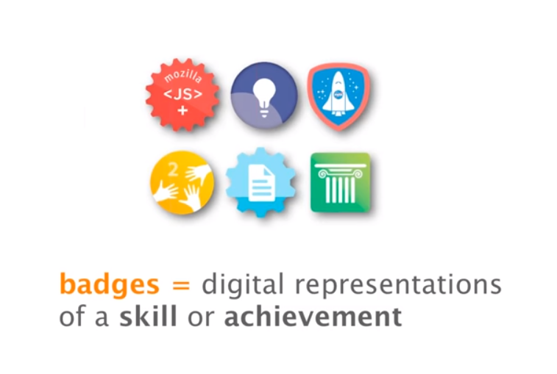

MyITLAB Microsoft Badges:
https://www.pearsonmylabandmastering.com/northamerica/myitlab/educators/badging/

MyITLab Earn Badges Instructions:
https://support.pearson.com/getsupport/s/article/MyITLab-Earning-Badges

MyITLab Frequently Asked Questions:
https://www.pearsonmylabandmastering.com/northamerica/myitlab/educators/badging/faqs/index.html

